Harrow Youth Offending Partnership

Youth Justice Plan

July 2018 - 2019

Contents

1. Foreword 3

2. Introduction 5

3. Executive Summary 6

4. Strategic Analysis / Annual report 8

Youth Crime 8

Caseloads 9

Education, Training and Employment (ETE) 9

YOT and Children Looked After / Children in Need 10

Caseload intensity, vulnerability and risk 11

Practice Performance and Quality Assurance 13

Ethnicity 14

Gender 15

Key Performance Objectives 16

Prevention Programmes (Triage) 17

Out of Court Disposals (OOCD) 18

First Time Entrants 18

Re-offending 22

Custody and Remand 23

Key Findings from the Strategic Assessment and VVE Strategy 26

5. Summary of Strategic Objectives 47

6. Delivering the strategy 48

7. Appendices 49

YOT Board Membership 49

Finance Table 50

Staffing structure and breakdown 51

Structure and Governance arrangements 52

Allocation of Good Practice Grant 53

YOT Champions Roles 54

Glossary 58

Statutory functions and strategic approach of the Youth Justice Board (YJB) 59

Consultation questionnaire 61

# Foreword



Councillor Christine Robson

Young People & Schools Portfolio Holder

This year we have deliberately closely aligned our Youth Justice Plan local strategic objectives, with the Violence Vulnerability and Exploitation (VVE) Strategy and with the Safer Harrow Strategic Assessment.

The recently published: “This is Harrow” young people’s needs analysis produced in collaboration with Young Harrow Foundation and involving an analysis of over 4500 young people’s questionnaires outlining their needs, highlighted gang activity and youth violence, mental health and emotional wellbeing as some of the key concerns of young people and themes to be addressed. These chime with the strategic objectives of this Youth Justice Plan.

Our strategic objectives within this plan are to

* Reduce Youth violence (particularly knife crime)
* Reduce Drug and alcohol misuse (including the use, supply and distribution as well as the exploitation of younger age groups into becoming involved)
* Strike a balance between protection of the public and safeguarding the welfare and wellbeing of those at risk of offending.
* Reduce the numbers of young people coming into the youth justice system, reduce the need for custody and reduce the rate of re-offending

There are a range of wonderful existing partnership arrangements with other statutory and voluntary sector organisations. We are all focused around these objectives and working together to build Harrow to become a great place to work, live and go to school. It is our aim and collective will to protect the most vulnerable and provide suitable support to families within our local communities.

The needs of young people will continue to be responded to. We will embrace the use of the recently launched rich new dataset coordinated through Young Harrow Foundation.

Local young people will continue to be engaged and involved in co-producing and reviewing the strategic developments, impact and successes as we move forward so that residents will be assured that we will continue to deliver our overarching vision of building a better Harrow.

# Introduction

All Youth Offending Teams are required to produce an annual review for the Youth Justice Board. Harrow’s Youth Justice plan is closely aligned to Harrow’s Violence, Vulnerability and Exploitation Strategy which is produced by Harrow’s community safety partnership known as ‘Safer Harrow’

This Youth Justice plan assesses the performance of the Youth Justice Partnership and Youth Offending Team against national (Youth Justice Board) and local priority strategic objectives and reviews the ongoing strategic objectives.

**The residents and young people of Harrow need to feel and be safe**

* The numbers of First Time Entrants to the youth justice system (young offenders coming into contact with the youth justice system for the first time) are decreasing and lower than the London and England averages.
* The numbers of young people receiving custodial sentences are decreasing and lower than the London and England averages
* The number of young people reoffending are all decreasing and performance is better than the London and UK averages.

**Nevertheless**, the crimes and issues being committed and displayed are increasingly complex, serious and undertaken by young people with higher levels of vulnerability as well as risk.

**The three strategic objectives** outlined within this strategy focus on

* Reducing Youth violence (particularly knife crime)
* Reducing Drug and alcohol misuse (including the use, supply and distribution as well as exploitation of younger age groups into such use)
* Striking a balance between protection of the public and safeguarding the welfare and wellbeing of those at risk of offending.

As with the Violence Vulnerability and Exploitation Strategy, this Youth Justice Plan also firmly **echoes the current Mayor’s priorities**, and includes a renewed focus on tackling Youth Violence, Drug and alcohol misuse and targeted support

The aligned plan considers the impact of youth offending and diversion from offending. The aligned plans consider an annual assessment of crime, disorder, anti-social behaviour, substance misuse and reoffending within the borough as is reported in Harrow’s Strategic Assessment. The Strategic Assessment previously came to Overview and Scrutiny along with the draft Community Safety Strategy. However, following feedback from scrutiny that this does not allow scrutiny sufficient opportunity for its comments and reflections on the strategic assessment to inform the refresh of the Community Safety Strategy, this year the strategic assessment came to Overview and Scrutiny separately, in March 2018. The Strategic Assessment is then used to inform the partnership’s Community Safety Strategy. The last Community Safety Strategy was published in 2017 and is refreshed on an annual basis.

**Consultation and Engagement**

In refreshing the strategy and priorities, consultation and engagement has been undertaken with some partners, stakeholders and relevant services within the council.

* 7th June 2018 – Draft strategy and strategic objectives discussed at Youth Offending Team Meeting for feedback and comments.
* 8th June 2018 – Draft strategy taken to Youth Offending Partnership Board for feedback and comments.
* 27th June 2018 – Draft Executive Summary and Strategic Objectives taken to Harrow Youth Parliament for feedback and comments
* 28th June 2018 - Draft Executive Summary and Strategic Objectives taken to Early Support Hub (Youth groups) for feedback and comments

The Violence Vulnerability and Exploitation Strategy with which this plan aligns has also been consulted on extensively and this benefits from such accord.

Harrow’s Community Safety Partnership, Safer Harrow, brings together many organisations that contribute to our ambition of making Harrow the Safest Borough in London. The Council’s vision is also “working together to make a difference for Harrow” and this is particularly relevant to the work of Safer Harrow, which as a Partnership is working together to achieve better and safer outcomes for people who live, work, visit and study in the borough.

The Youth Offending Partnership Board has strategic oversight of the Youth Offending Team who, along with collaborative partnerships, deliver aligned strategic objectives to the young people of Harrow who are vulnerable to or impacted by offending.

The structure of this report includes a strategic analysis of the latest data available (2016-17) and then lays out the strategic objectives before a consideration of how these objectives will be taken forward.

A number of relevant appendices then outline and give more detail about relevant operational matters.

# Executive Summary

**The residents and young people of Harrow need to feel and be safe**

1. The welfare and wellbeing of young people at the edge of and involved in offending behaviour and the protection of the people and community affected by such offending remain at the heart of the challenges for this YOT service.
   1. Achieving a balance which promotes welfare and wellbeing and also enables feeling of and actual safety and protection continues to be managed and led by the officers and staff of the partnership.
   2. This collaborative and inclusive approach needs to continue as partners work together to develop effective and innovative ways to manage the challenges and serve in order to lead relevant and proportionate achievements.
2. Responding to local needs including being involved with the Wealdstone and South Harrow/Rayners Lane Community Action Groups will help deliver the strategic objectives. This will build on work already being delivered from the Wealdstone Early Support (Youth) Hub and in partnership with youth provision / services delivered out of the Beacon centre.
3. There is a strong and positive improvement in the three key performance areas established through the Youth Justice Board
   1. The rate of first time entrants to the Youth Justice System in Harrow continues to decline and is lower than the London, and England average rate.
   2. The use of custody remains very low during 2017-18 and is lower than the London, and England average rate.
   3. The rate of reoffending is decreasing and is lower than the London, and England average rate.
4. There is a fully recruited and stable staff group with suitable skills and abilities to deliver high quality services and interventions to the young people being worked with. The co-located nature of the service continues to be a strength.
5. There is a strong alignment with Youth Offer. The Early Support Service has enabled a restructuring to further strengthen the pathways to divert young people from offending behaviour and link in with Youth service which is now formally a part of a restructured continuum of provision.
6. There is a good alignment with the work of the Violence, Vulnerability and Exploitation (VVE) partnership. This includes collaborative working at VVE daily meetings, working with partner agencies (MASH Police) and strategic alignment. There is also close alignment with the Joint Strategic Assessment which has informed both the VVE Strategy and this plan.
7. Local challenges for young people and the workers of the YOT include
   1. Addressing vulnerability to becoming involved in serious youth violence and
   2. Being vulnerable to being exploited and involved in the use, supply and distribution of illegal drugs.
8. Relationships and collaborative working with Children’s Services continue to strengthen and build on good arrangements. About a third of YOT young people are also known to Children’s Services Partners.
9. The YOT continue to support, develop and promote a range of effective and innovative programmes including “mindfulness and mental toughness”, “street doctors” and “Goldseal: music production” to name just a few.
10. The service continues to build a closer affinity with the voluntary sector including Ignite and Young Harrow Foundation.
11. The YOT is motivated to understand and build on identified areas for improvement and have commissioned Wrightlink to enable an audit of work in order to test and prepare against the updated regulatory framework.
12. Asset Plus has been continuing to embed within the service July 2017. Though there have been some challenges, the use of AssetPlus is starting to show some benefits in terms of enabling better identification of risk and vulnerability which is enabling enhanced abilities to manage these aspects.

# Strategic Analysis / Annual report

## Youth Crime

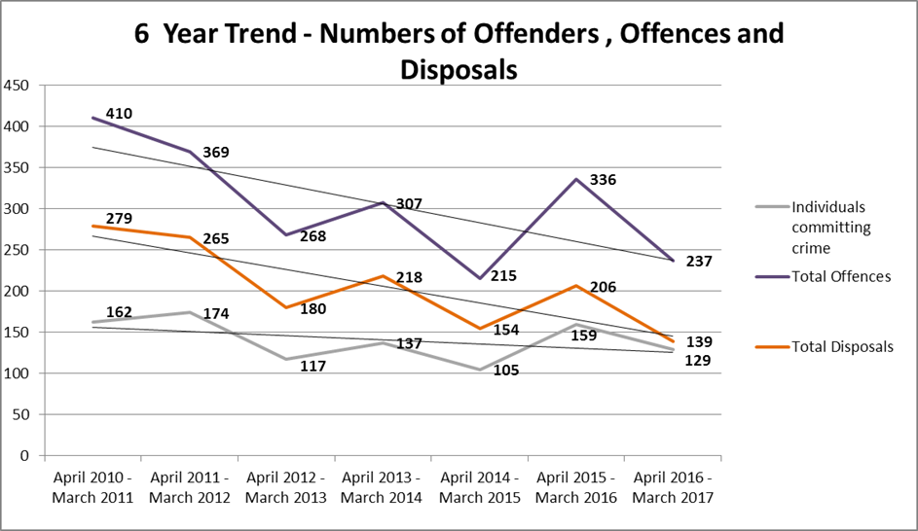

Overall youth crime has been variable over the past 6 years but the general trend is a gradual decrease in numbers of orders, offences committed and numbers of young people committing offences.

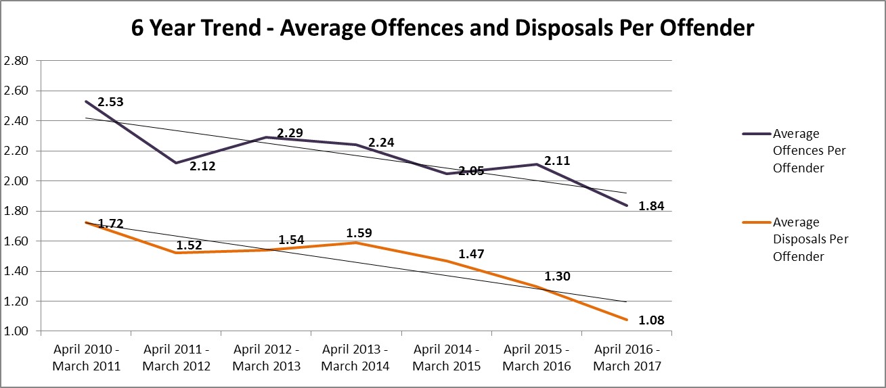

The revised out of court disposal process allows police to offer out pre court disposals for a wider range of offences, and consider factors such as remorse at point of arrest has allowed for a more meaningful disposal which can assist in the diversion from the Youth Justice System. It is also possible that cautions are being used more frequently which may be contributing to the decreasing number of disposals.

Although the general trend shows a decreasing average number of offences and disposals per offender, 2016/17 has seen some changes in the distribution of disposal types being issued. The most notable change is a **7% decrease** (down to 28%) in the proportion of youth rehabilitation orders (**community disposals**), and a **6% increase** (up to 50%) in the proportion of referral orders (**first tier disposals**).

## Caseloads



The YOT caseload had started to increase again during 2017/18 after falling in 2016/17, as low as 97 in Q1. This was reflective of an increase in the number of interventions open to the YOT during 2017/18 and an increase in the number of individuals being worked with (a 7.4% increase against 16/17).

## Education, Training and Employment (ETE)

|  |  |  |  |  |  |  |  |
| --- | --- | --- | --- | --- | --- | --- | --- |
| **Current ETE for Open Interventions** | | | | | | | |
|
| **Actively engaged in ETE** | **Total In Age Group** | **Total Actively Engaged** | **% Actively Engaged** | **Engaged in ETE for less than standard Hrs.** | **% Engaged in ETE for less than standard Hrs.** | **Total NEET** | **% NEET** |
| Statutory School Age (25+ Hrs. ETE) | 36 | 27 | 75.0% | 4 | 11.1% | 5 | 13.9% |
| Non Statutory School Age (16+ Hrs. ETE) | 34 | 22 | 64.7% | 0 | 0.0% | 12 | 35.3% |
| **Total** | **70** | **49** | **70.0%** | **4** | **5.7%** | **17** | **24.3%** |

Harrow’s local target for young people in Education, training or employment (ETE) is 75%. The ETE status for the active caseload is 70.0%, which compares to 78.4% in the previous year.

The snapshot shows that 75.0% of young people aged 10-16 were accessing 25+hours of education and 64.7% of those aged 17-18 years were accessing 16+ hours. Detailed reports are provided on a quarterly basis to the YOT board on all NEET young people.

## YOT and Children Looked After / Children in Need

A snapshot of the YOT current caseload in March 2017 shows that there were a total of 9 young people who were also looked after, this represents 11.5% of the YOT caseload. In addition to this 14 (17.9%) were classed as children in need and 4 (5.1%) were on a child protection plan.

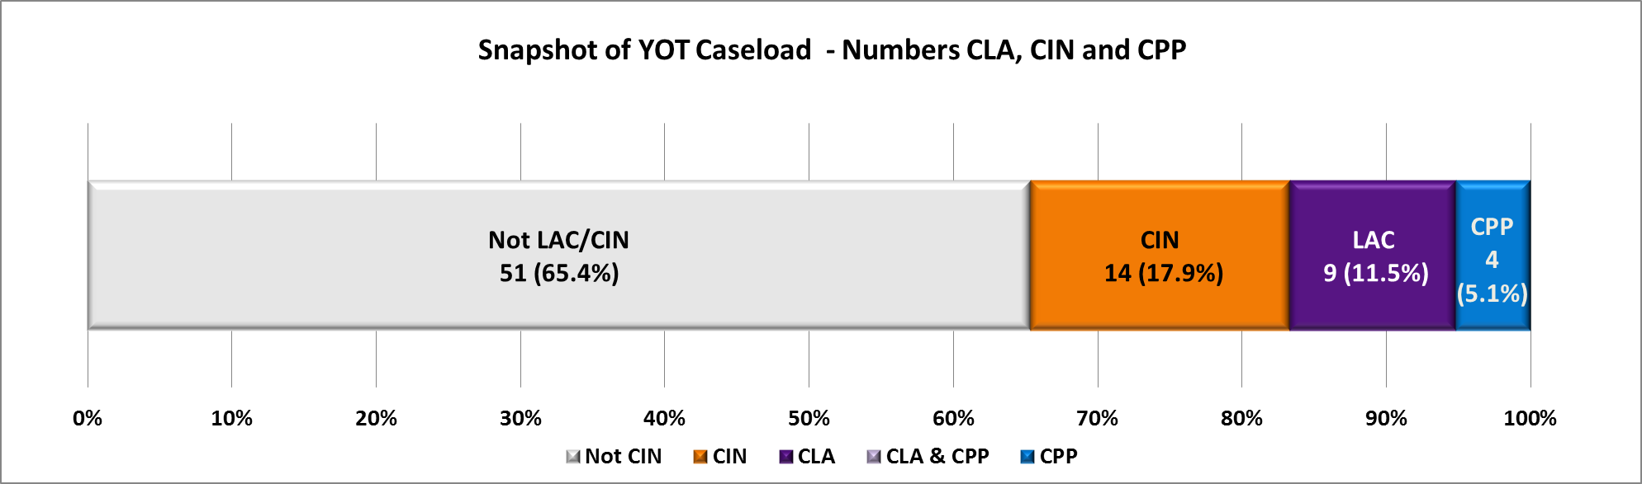

Research into first time entrants and the active caseload carried out in November 2014, supported the perception that looked after children in Harrow were more at risk of re-offending.

The snapshot data for children looked after in March 2017 shows that on the whole a higher proportion of the LAC caseload are re-offenders than the general YOT population. Of the 9 young people looked after, 6 (66.6%) had been re-offenders with only 3 (33.3%) being first time entrants, this compares to only 41.3% of the YOT caseload who are re-offenders.

## Caseload intensity, vulnerability and risk

### Intensity

2017/18 has seen a slight decrease in the proportion of the caseload assessed as “intensive” (requiring the most amount of contact), from 56.6% to 54.3%. In all there is only a slight change to the complexity of the caseload during 2017/18.

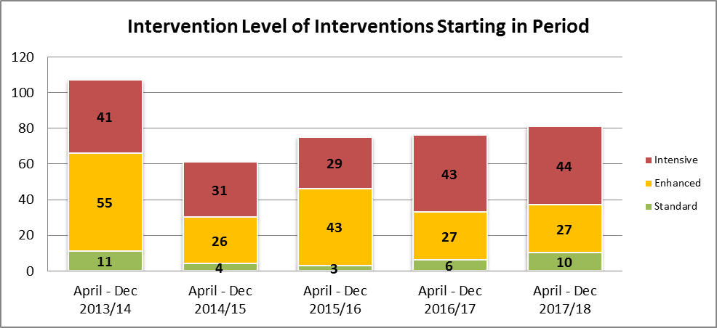

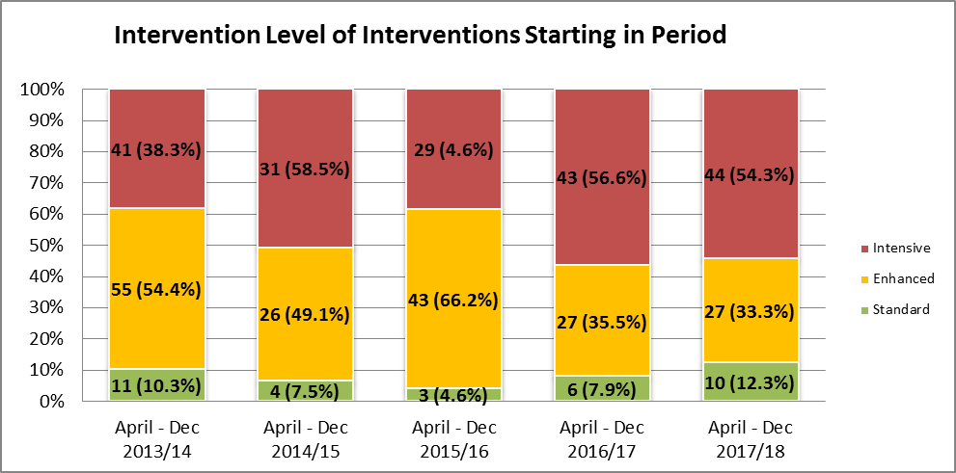

### The proportion of higher vulnerable cases has increased.

In 2017/18 there were 38 (47% of) cases assessed as high or very high vulnerability.

In 2016/17 there were 23 (30% of) cases assessed as high or very high vulnerability

At the same time low vulnerability cases have decreased from 28% in 2016/17 to 15%.

It is likely that Asset Plus has supported better identification of higher levels of vulnerability. However, the increase reflects that there is also a likely increase in the number of more vulnerable young people.

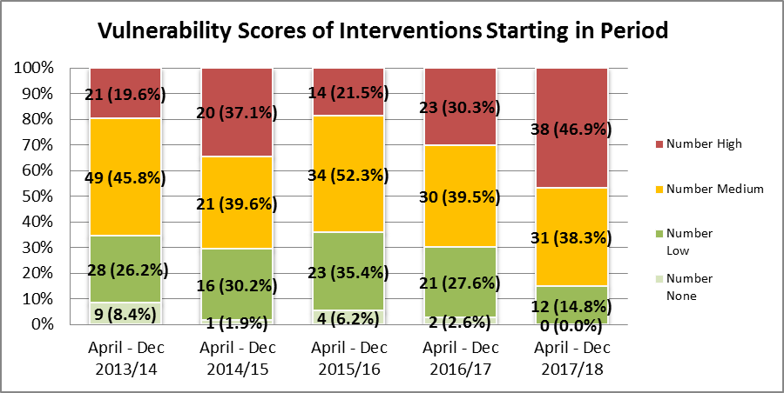

### Assessed Levels of risk have shown a slight decrease

In 2017/18 there were 32 (40% of) cases assessed as high / very high vulnerability

In 2017/16 there were 33 (43% of) cases assessed as high / very high vulnerability

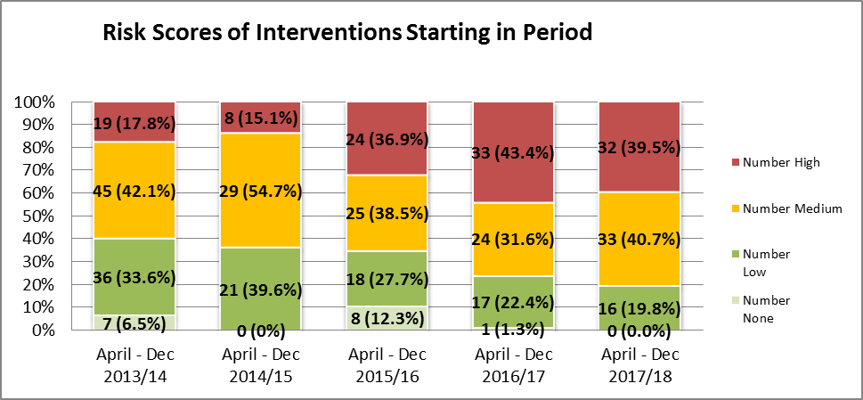

## Practice Performance and Quality Assurance

Regular performance monitoring has been embedded within the YOT over the past three years. Performance support and regular monthly and weekly reports have continued to be developed to ensure timeliness and compliance of key processes in line with national standards. A monthly scorecard was developed to incorporate local and national indicators and is overseen by the YOT management board. This has been in use for the past three years. 2017/18 has seen a change in the internal indicators to reflect new practice requirements in line with the introduction of ASSET plus. Due to new indicators for 2017/18, there is no comparison available for previous years. The table below represents the key targets for 2017/18.

|  |  |  |  |  |  |  |  |  |  |  |  |  |  |
| --- | --- | --- | --- | --- | --- | --- | --- | --- | --- | --- | --- | --- | --- |
| **Month** | **Apr-17** | **May-17** | **Jun-17** | **Jul -17** | **Aug-17** | **Sep-17** | **Oct-17** | **Nov-17** | **Dec-17** | **Jan-18** | **Feb-18** | **Mar-18** | **YTD** |
| % of New interventions with initial assessment completed and signed of within 35 Days | New measure starting from August 2017 | | | | 6.7% | 33.3% | 0.0% | 22.2% | 25.0% | 20.0% | 12.5% | 14.3% | **16.3%** |
| % of New interventions with Home Visits within 28 days | 44.4% | 50.0% | 66.7% | 43.8% | 36.4% | 33.3% | 66.7% | 75.0% | 66.7% | 75.0% | 83.3% | 62.5% | **55.7%** |

Countersigning of initial ASSET plus has been variable during 2017/18 with an overall annual figure of 16.3%. Figure are low for countersigning overall in 17/18. Harrow YOT implemented Asset Plus less than a year ago. Other YOTs have reported that it has been taking 18-24 months to properly embed the system. There was previously some data loss issues resulting in the inability to technically sign off some assessments. The system does not generate a notification regarding signing off so is reliant on the worker effectively informing the manager to check the system. Quality Assurance (QA) process happens before the technical sign off. Harrow YOT have a policy of quality assuring all cases not just the high risk ones. There have been some capacity issues regarding the QA process however, all posts are now back or coming back on stream. Lastly, though the proportions look low, the actual numbers are low too so will hopefully show significant improvements just by taking suitable action on a relatively low and achievable number. However, this issue is acknowledged and will be subject to ongoing performance management.

Home visits have also been variable during 17/18 with an overall figure of 55.7%. This compares to 59.2% for 2016/17.

## Ethnicity

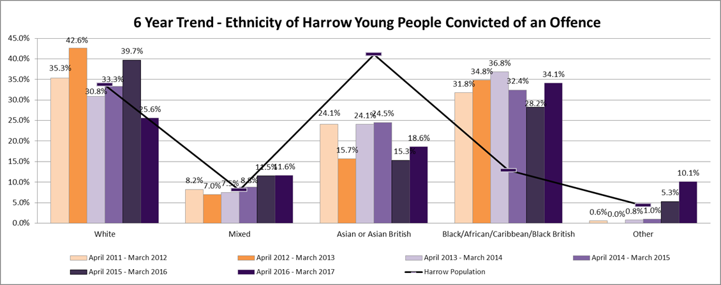

Over the past 6 years (2011/12 to 2016/17), Harrow has seen some key changes to the ethnic make-up of its offending population as displayed on the graph above.

The most notable difference between local demographics and youth offending demographics can be seen in the Black / African / Caribbean / Black British group. This group are considerably over represented, making up only 13% of Harrow’s 10-17 population but 34 % of the youth offending population in 2016/17. This group have been consistently over represented in youth offending services.

In addressing this, the YOT have developed a number of responses:

* A targeted BAME group has started within the last couple of months: Project Empire to Inspire. This promotes resilience and leadership skills and is open to any young people in the YOT from Triage to Licence.
* All workers attend inset training on Unconscious Bias
* The YOT provide challenge back to partners about disproportionality in triage / Out of Court disposals / First Time Entrants.
* Court User Group attended by managers and advice and guidance provided.
* There will be consideration of further developing the Youth Offer to address disproportionality.

## Gender

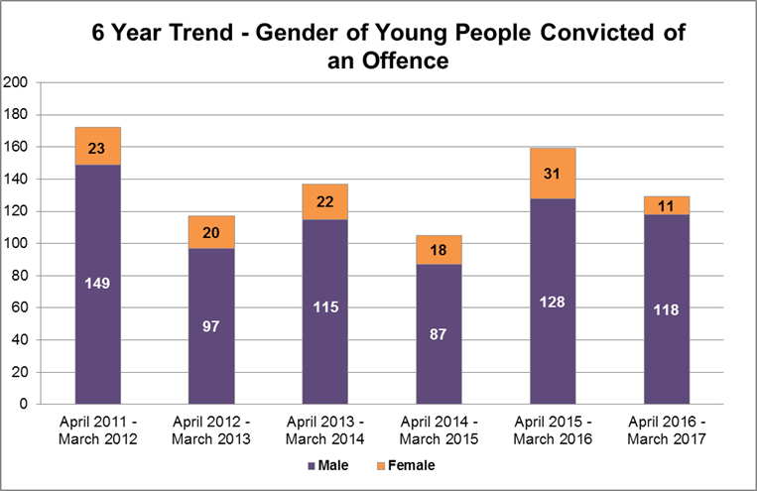

2016/17 represents a significant decrease in the proportion of YOT clients who are female (8.5%). The National Average for females is 15.4% and London Average is 13.7%.

Within the prevention programmes (Triage) there are some clear differences seen in the types of offending between males and females. Females are less likely to commit drug offences, 12% (2/13) compared to 31% (18/41) for males. However, females are more likely to commit violence against the person offences, 35.3% (6/13) compared to 15.5% (9/41) for males.

The small numbers involved here may make it difficult to think of this as disproportionality however, there are thoughts on developing programmes specific for females at risk of committing violence against the person offences. It is possible that some of the high proportions here relate to domestic abuse in which young women and girls have been reported as fighting with parents / siblings. There is a suggestion for considering a female specific mindfulness group though due to the low numbers this may have to be combined with Early Support / Youth Offer which suitably managing any assessed risks inherent in this solution. There is possible potential to develop something to be linked with the schools provision/projects.

## Key Performance Objectives

|  |  |  |  |  |
| --- | --- | --- | --- | --- |
|  | **Harrow** | **London** | **YOT Family** | **England** |
| **First Time entrants PNC rate per 100,000 of 10-17 population **Good performance is typified by a negative percentage** |  |  |  |  |
| **Oct 16 - Sep 17 (Latest Period)** | **260** | **394** | **313** | **304** |
| Oct 15 - Sep 16 | 349 | 401 | 353 | 340 |
| *percent change from selected baseline* | -25.4% | -1.7% | -11.3% | -10.7% |
|  | | | | |
| **Use of custody rate per 1,000 of 10-17 population **Good performance is typified by a low rate** |  |  |  |  |
| **Jan 17 - Dec 17 (Latest Period)** | **0.34** | **0.67** | **0.36** | **0.38** |
| Jan 16 - Dec 16 | 0.34 | 0.69 | 0.42 | 0.39 |
| *change from selected baseline* | 0.00 | -0.03 | -0.07 | -0.01 |
|  | | | | |
| **Reoffending rates after 12 months - Three month cohorts** |  |  |  |  |
| **Re-offences per reoffender Jan 16 - Mar 16 cohort (latest period)** | **1.60** | **3.66** | **3.64** | **3.85** |
| Re-offences per reoffender Jan 15 - Mar 15 cohort | 2.61 | 3.41 | 3.16 | 3.64 |
| *change from selected baseline* | -38.7% | 7.2% | 15.3% | 6.0% |
|  | | | | |
| **Reoffending rates after 12 months - Aggregated quarterly cohorts (12 months cohort) This data is only given annually for April to March.** |  |  |  |  |
| **Re-offences per reoffender Apr 15 - Mar 16 cohort (latest period)** | **2.73** | **3.47** | **3.56** | **3.78** |
| Re-offences per reoffender Apr 14 - Mar 15 cohort | 2.82 | 3.43 | 3.18 | 3.61 |
| *change from selected baseline* | -3.0% | 1.2% | 12.0% | 4.6% |

Harrow’s YOT has seen good progress in its reduction in first time entrants compared to the previous year with a reduction of 25.4%. Harrows current rate of 260 is considerably lower than London, National and YOT family averages.

Re-offending rates compared to the previous year have decreased by 7.9%. The current figure of 37.1% is lower than all comparator figures. This steep reduction is not reflected in comparator figures which are only showing minimal changes.

Harrow’s use of custody rate has remained the same at 0.34. This is in contrast to slight reductions in comparator figures. Despite no change for Harrow the figure of 0.34 is still lower than comparator figures.

Relationships/building trust is key. Having a stable workforce is contributing to lower numbers of reoffending. The service is hoping to develop a targeted programme for serious youth violence from a victim perspective (developing empathy etc) but this is currently only at the scoping phase.

## Prevention Programmes (Triage)

During 2017/18 the YOT received 36 referrals, 32 of which went on to have a triage intervention and 4 were sent back to police for non-engagement. Overall; including those already with triage at the start of the year; **the team delivered triage interventions to 54 young people**. There were a total of 49 young people discharged from the triage programme in 2017/18, 49 (92%) of whom completed the programme successfully.

**This represents a significant decrease from 2016/17 where 75 triage interventions were delivered** to young people.

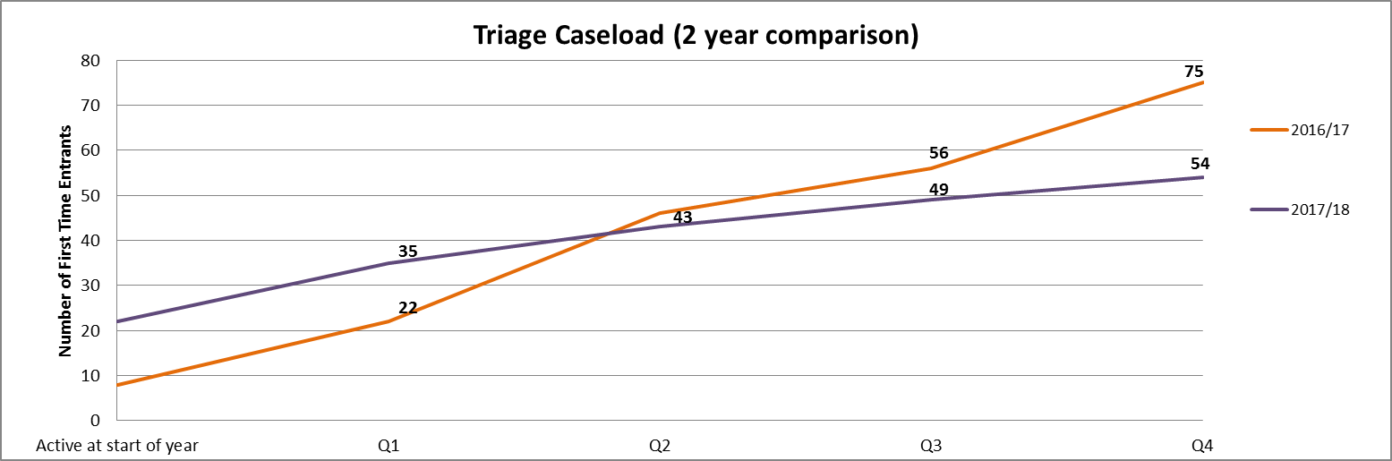

**Gender** make up of those subject to triage is similar to last year (2016/17: 23% female, 2017/18: 24% female).

**Age:** 17/16/15 year olds made up 69%, 14 year olds 11% and 13/12/11 year olds made up 20% of the 2017/18 triage cohort.

**Type of offences** within the triage cohort

|  |  |  |  |  |  |  |
| --- | --- | --- | --- | --- | --- | --- |
|  | **All** | | **Male** | | **Female** | |
| **Offence Type** | **Number** | **%** | **Number** | **%** | **Number** | **%** |
| Drugs | 20 | 37% | 18 | 44% | 2 | 15% |
| Burglary | 1 | 2% | 1 | 2% | 0 | 0% |
| Fraud | 2 | 4% | 2 | 5% | 0 | 0% |
| Other | 1 | 2% | 1 | 2% | 0 | 0% |
| Public Order | 1 | 2% | 0 | 0% | 1 | 8% |
| Theft | 8 | 15% | 4 | 10% | 4 | 31% |
| Theft And Handling Stolen Goods | 6 | 11% | 6 | 15% | 0 | 0% |
| Violence Against The Person | 15 | 28% | 9 | 22% | 6 | 46% |
| **Total** | 54 | 100% | 41 | 100% | 13 | 100% |

Although the numbers are small, females are less likely to commit drug offences and are more likely to commit theft and violence against the person offences than males.

## Out of Court Disposals (OOCD)

During 2017/18 there were a total of 12 out of court disposals. This includes 2 youth conditional cautions that were already active at the start of the year and 10 new out of court disposals starting in the year, all youth conditional cautions.

|  |  |
| --- | --- |
| **Offence Type** | **Number** |
| Drugs | 1 |
| Fraud | 1 |
| Public Order | 2 |
| Theft | 2 |
| Violence Against The Person | 6 |
| **Total** | **12** |

All 12 of the young people subject to out of court disposals were first time entrants.

At the end of May 2018, none of the 12 had re-offended.

## First Time Entrants

|  |  |  |  |  |  |  |  |
| --- | --- | --- | --- | --- | --- | --- | --- |
|  | **First time entrants** | | | | | | |
| **Harrow** | | | **YOT Family Average** | | **National Average** | |
| **Number** | **Rate per 100,000** | **% change from previous year** | **Rate per 100,000** | **% change from previous year** | **Rate per 100,000** | **% change from previous year** |
| Oct 15 - Sep 16 | 61 | 260 | -25.5% | 317 | 8.6% | 304 | -9.0% |
| Oct 15 - Sep 16 | 82 | 349 | -7.9% | 292 | -8.8% | 334 | -11.2% |
| Oct 14 - Sep 15 | 89 | 379 | 20.3% | 320 | 3.2% | 376 | -11.7% |
| Oct 13 - Sep 14 | 73 | 315 | -3.7% | 310 | -13.9% | 426 | -8.4% |
| Oct 12 - Sep 13 | 79 | 327 | -24.5% | 360 | -25.0% | 465 | -22.1% |
| Oct 11 - Sep 12 | 105 | 433 | -9.0% | 480 | -26.2% | 597 | -21.8% |
| Oct 10 - Sep 11 | 115 | 476 | - | 650 | - | 763 | - |

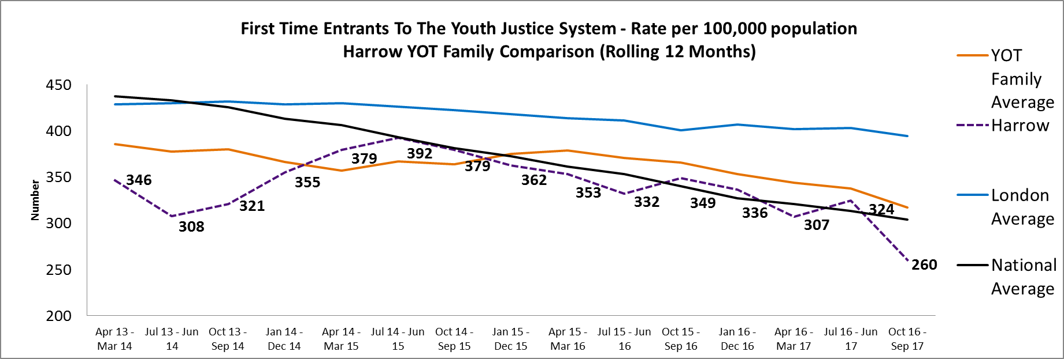

Since 2014/15 Harrow has seen a general downward decrease in the number of first time entrant. This is a trend which has been reflected nationally and across London. Harrow has seen a reduction of 26% in first time entrants during the latest reporting period (Oct 16 – Sep 17) with 62 individuals compared to 82 in the previous year (Oct 15 – Sep 16). This is the lowest number of FTE’s that harrow has ever reached.

Note: The local figure will differ from the national figure as the national figure takes into account offences that may not be recorded on the local system, such as offences receiving a police caution or young people who are the responsibility of another borough but whose address may be in harrow.

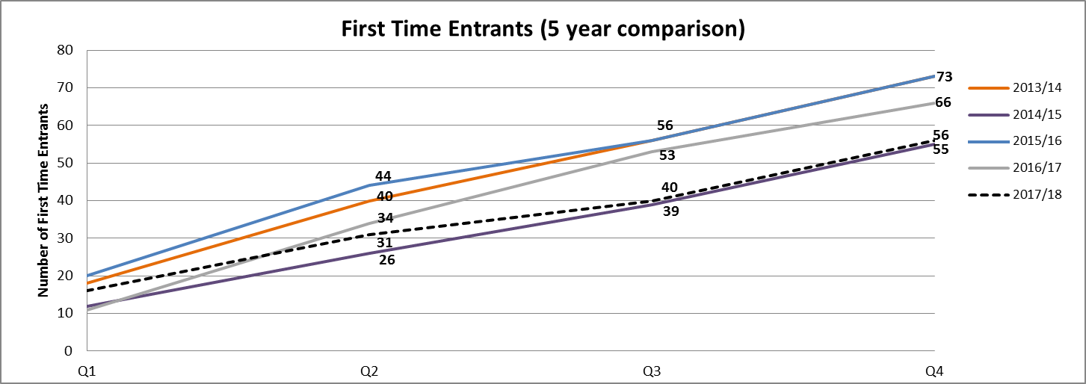

FTE Outcomes types for 2016/17 and 2017/18 were mostly similar with a few noticeable variations.

The reduction in first time entrants is mostly due to decrease in new out of court disposals. FTE’s with conditional cautions have been decreasing year on year with 0 in 2017/18 compared to 2 in 2016/17 and 9 in 2015/16. This pattern can also be seen with Youth Conditional Cautions, 5 (8.9%) in 2017/18 compared to 10 (15.2%) in 2016/17 and 11 (15.1%) in 2015/16.

There are similar numbers of referral orders and youth rehabilitation orders in 2017/18 as in previous years. However, they make up a higher proportion of the total caseload.

Referral orders were 40 (56.2%) in 2015/16, 43 (65.2%) in 2016/17 and 42 (75.0%) in 2017/18. Youth Rehabilitation Orders were 7 (9.6%) in 2015/16, 5 (7.6%) in 2016/17 and 8 (14.3%) in 2017/18.

There has been an overall reduction in FTE’s receiving custodial sentences with only 1 (1.8%) in 2017/18, compared to 4 (6.1%) in2016/17.

|  |  |  |  |  |  |  |
| --- | --- | --- | --- | --- | --- | --- |
|  | **2015/16 Total** | | **2016/17 Total** | | **2017/18 Total** | |
| **Outcome** |  |  |  |  |  |  |
| Absolute Discharge | 1 | 1.4% | 0 | 0.0% | 0 | 0.0% |
| Fine | 1 | 1.4% | 0 | 0.0% | 0 | 0.0% |
| Conditional Discharge | 2 | 2.7% | 2 | 3.0% | 0 | 0.0% |
| Conditional Caution | 9 | 12.3% | 2 | 3.0% | 0 | 0.0% |
| Youth Conditional Caution | 11 | 15.1% | 10 | 15.2% | 5 | 8.9% |
| Referral Order | 40 | 56.2% | 43 | 65.2% | 42 | 75.0% |
| Youth Rehabilitation Order | 7 | 9.6% | 5 | 7.6% | 8 | 14.3% |
| Section 91 Order | 1 | 1.4% | 0 | 0.0% | 0 | 0.0% |
| Section 90-92 Detention | 1 | 1.4% | 0 | 0.0% | 0 | 0.0% |
| Detention and Training Order | 0 | 0.0% | 4 | 6.1% | 1 | 1.8% |
| **Total** | 73 |  | 66 |  | 56 |  |

Of the 56 first time entrants in 2017/18, 54 (96.4%) were male and 2 (3.6%) were female. This is a reduction in the proportion of FTE’s who are female with 3.6% in 2017/18 compared to 15.2% in 2016/17.

17 year olds (28.6%) and 16 year olds (28.6%) were the largest age groups in 2017/18 followed by 15 year olds (21.4%) and 14 year olds (8.9%). During 2017/18 there were no 18 year olds becoming FTE’s compared to 2016/17 where they made up 13.6% of the caseload. Overall, FTE’s tended to be younger in 2017/18 than in the previous year with a higher proportion (21.4%) being 14 and under compared to 2016/17 (13.6%).

|  |  |  |
| --- | --- | --- |
| **Offence Type** | **Number** | **%** |
| Criminal Damage | 4 | 7.1% |
| Drugs | 9 | 16.1% |
| Other | 1 | 1.8% |
| Public Order | 1 | 1.8% |
| Robbery | 7 | 12.5% |
| Theft And Handling Stolen Goods | 4 | 7.1% |
| Fraud | 1 | 1.8% |
| Violence Against The Person | 29 | 51.8% |
| **Total** | **56** |  |

Of the 56 young people who were first time entrants in 2017/18, offences falling into the violence against the person category are most frequent accounting for 51.8 %, followed by Drug offences (16.1%), Robbery (12.5%), theft and handling stolen goods (7.1%) and criminal damage (7.1%). Violence against the person offences were primarily possessions of knives or other offensive weapons (20 cases- 35.7%) with the rest being Assaults (9 cases - 16.1%).

### Triage/OOCD/ FTE Comparisons

|  |  |  |  |  |  |  |
| --- | --- | --- | --- | --- | --- | --- |
|  | **Triage** | | **OOCD** | | **FTE** | |
| **Offence Type** | **Number** | **%** | **Number** | **%** | **Number** | **%** |
| Criminal Damage | 0 | 0.0% | 0 | 0.0% | 4 | 7.1% |
| Drugs | 20 | 37.0% | 1 | 8.3% | 9 | 16.1% |
| Burglary | 1 | 1.9% | 0 | 0.0% | 0 | 0.0% |
| Fraud | 2 | 3.7% | 1 | 8.3% | 1 | 1.8% |
| Other | 1 | 1.9% | 0 | 0.0% | 1 | 1.8% |
| Public Order | 1 | 1.9% | 2 | 16.7% | 1 | 1.8% |
| Robbery | 0 | 0.0% | 0 | 0.0% | 7 | 12.5% |
| Theft | 14 | 25.9% | 2 | 16.7% | 4 | 7.1% |
| Violence Against The Person | 15 | 27.8% | 6 | 50.0% | 29 | 51.8% |
| **Total** | **54** | **100.0%** | **12** | **100.0%** | **56** | **100.0%** |

Offence types vary between first time entrants, triage and out of court disposals. The most noticeable difference is Violence against the person offences with 51.8% for first time entrants, 50.0% for out of court disposals and 27.8% for triage. Knife and offensive weapons offences are higher in the first time entrant’s category with 35.3% of offences being for offensive weapons compared to only 11.1% in the triage group. Most of the first time entrants that were sentenced for Knife/offensive weapons offences received a referral order.

Theft and handling stolen goods are seen much more frequently in the triage group (35.9%), compared to out of court disposals (16.7%) and first time entrants (17.1%). Drug offences are also seen more frequently in the triage group (37.0%) compared to out of court disposals (8.3%) and first time entrants (16.1%). Those committing robbery type offences only fall into the first time entrant’s category making up 12.5% of the first time entrants. All those with a robbery offence were sentenced to referral orders or youth rehabilitation orders.

|  |  |  |  |  |  |  |
| --- | --- | --- | --- | --- | --- | --- |
|  | **Triage** | | **OOCD** | | **FTE** | |
| **Ethnicity** | **Number** | **%** | **Number** | **%** | **Number** | **%** |
| Asian | 16 | 29.6% | 2 | 16.7% | 7 | 12.5% |
| Black | 11 | 20.4% | 3 | 25.0% | 23 | 41.1% |
| Mixed | 8 | 14.8% | 2 | 16.7% | 15 | 26.8% |
| Other | 2 | 3.7% | 0 | 0.0% | 1 | 1.8% |
| White | 16 | 29.6% | 5 | 41.7% | 5 | 8.9% |
| Missing Ethnicity | 1 | 1.9% | 0 | 0.0% | 5 | 8.9% |
| **Total** | **54** | **100.0%** | **12** | **100.0%** | **56** | **100.0%** |

Comparisons between those receiving triage, out of court disposals and those becoming first time entrants in 2017/18 show some considerable variations in ethnicity. This is reflective of the referrals in.

|  |  |  |  |  |  |  |
| --- | --- | --- | --- | --- | --- | --- |
|  | **Triage** | | **OOCD** | | **FTE** | |
| **Age** | **Number** | **%** | **Number** | **%** | **Number** | **%** |
| 11 | 4 | 7.4% | 0 | 0.0% | 0 | 0.0% |
| 12 | 3 | 5.6% | 2 | 16.7% | 3 | 5.4% |
| 13 | 4 | 7.4% | 0 | 0.0% | 4 | 7.1% |
| 14 | 6 | 11.1% | 3 | 25.0% | 5 | 8.9% |
| 15 | 12 | 22.2% | 3 | 25.0% | 12 | 21.4% |
| 16 | 11 | 20.4% | 1 | 8.3% | 16 | 28.6% |
| 17 | 14 | 25.9% | 3 | 25.0% | 16 | 28.6% |
| 18 | 0 | 0.0% | 0 | 0.0% | 0 | 0.0% |
| **Total** | **54** | **100.0%** | **12** | **100.0%** | **56** | **100.0%** |

The first time entrants tended to be slightly older, with 57.1% being 16 plus compared to 46.3% for triage and 33.3% for out of court disposals. 11 and 12 years olds were mostly seen in the OOCD group (16.7%) and triage group (13%), with only 5.4% in the first time entrants group.

## Re-offending

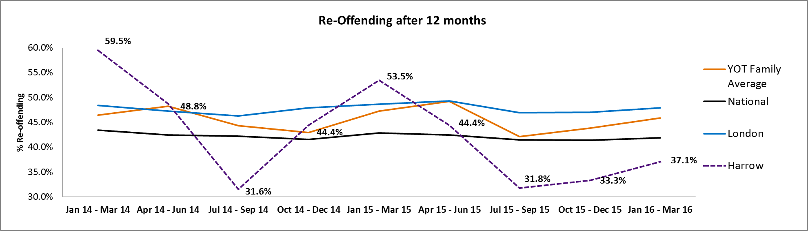

The Ministry of Justice has changed the methodology for measuring reoffending. There has been a move to a three month cohort rather than a 12 month cohort. The cohort will still be tracked over 12 months. Changing from 12 month cohorts to the 3 month cohorts results in a greater proportion of prolific offenders and thus the re-offending rates appear higher than previously. This rise is universal and seen nationally but this results in a greater variance at a local level. There is less historic data for the new measure and the YJB have only provided backdated information for 2 years.

Harrow's figures have been variable over the last couple of years with the highest point reaching 59.5% and the lowest 31.8%. Harrow's current figure (Jan 16-Mar 16) is 37.1%, this compares to 53.5% for the same period last year (Jan 15-Mar 15). This is lower than comparator YOT's (45.9%), national figure (41.9%) and London figure (47.9%).

The latest figure of 37.1% (Jan 16-Mar 16) represents a 15.0% reduction on the previous year’s figure of 53.5% (Jan 15-Mar 15). This reduction is not reflected in comparator figures with London and YOT family figures only decreasing slightly.

Harrow's current figure (Jan 16-Mar 16) is 37.1% accounts for 10 re-offenders from a cohort of 26. For the same period last year (Jan 15-Mar 15) this was 53.5% and accounted for 23 re-offenders from a cohort of 43.

A further measure of Re-offending is the re-offences per re-offender rate. This is the average number of re-offences committed by each re-offender. For Harrow the most recent figure is 1.60 (Jan 16 - Mar 16), this is a 38.7% reduction on the previous year’s figure of 2.61 (Jan 15 - Mar 15). Comparator data is higher for London (3.66), YOT family group (3.64) and national (3.85). Comparators have all increased, YOT families by 15.3% and London by 7.2%.

## Custody and Remand

### National Custody Data

Over the past 3 years, Harrow's numbers in custody have been varied from between 5 and 14 in any 12 month rolling period. The current quarter (Jan 17 - Dec 17) figure of 8 is the same as the previous year’s figure of 8 (Jan 16 - Dec 16).

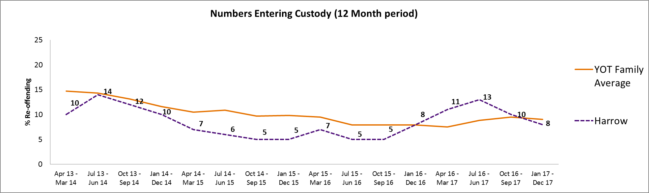

The custody rate per 1,000 indicators allows for a better comparison between YOT's performance. Overall, Harrow's current position of 0.34 (Jan 17 - Dec 17) is the same as the previous year’s figure of 0.34 (Jan 16 - Dec 16). Harrow is currently slightly lower than the YOT family average of 0.36 and lower than the London average (0.67) and national average (0.38).

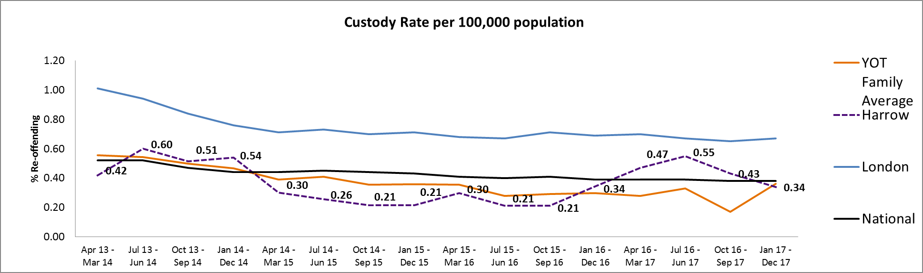

Unlike other indicators, there is no significant trend in the number of custodial sentences across the YOT family group.

### Local Custody Data

|  |  |  |  |  |  |  |
| --- | --- | --- | --- | --- | --- | --- |
| **Annual Numbers in custody April - March** | **2012 / 13** | **2013 / 14** | **2014 / 15** | **2015 / 16** | **2016 / 17** | **2017 / 18** |
| Total custodial sentences open at the start of the year | 8 | 13 | 8 | 3 | 5 | 5 |
| Total custodial sentences starting in year | 20 | 10 | 7 | 7 | 11 | 7 |
| Total in custody during year | 28 | 23 | 15 | 10 | 16 | 12 |

The general trend for Harrow, which was reflected nationally, had been a considerable decrease in the number of young people in custody up until 2015/16, falling from 24 new custodial sentences in 2012/13 to 7 in 2015/16. However, 2016/17 and 2017/18 have seen increase 11 new custodial sentences in 2016/17 and 7 in 2017/18.

At the start of 2017/18 Harrow had 5 young people on custodial sentences, there have been a further 7 new custodial sentence's during the year.

At the end of March 2018 there were 3 young people in custody and 2 young people on a post custodial licence.

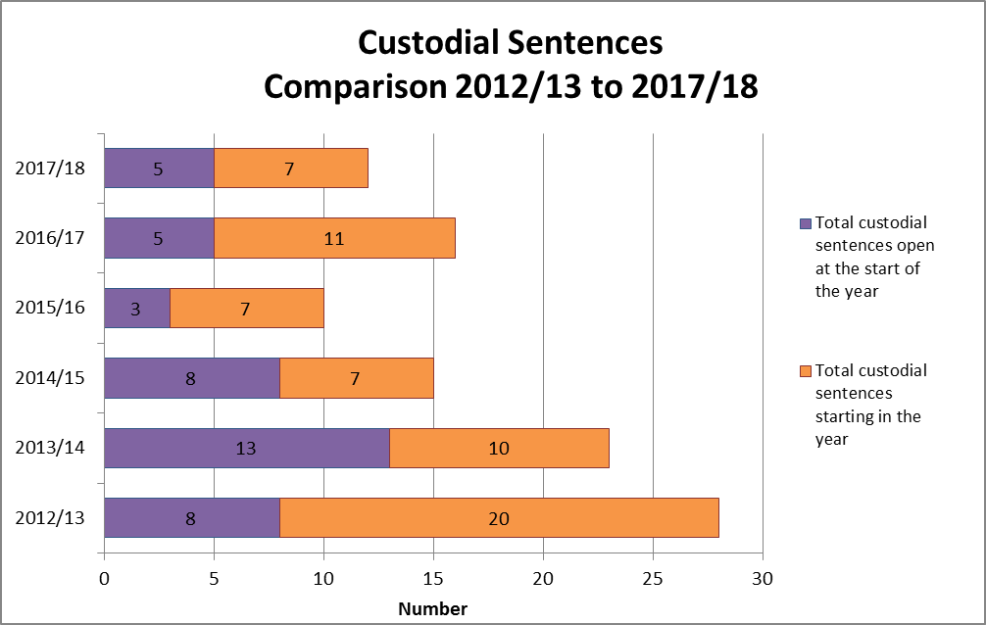

### Remand Data (Local)

|  |  |  |
| --- | --- | --- |
| **Annual Remand Figures April - March** | **Remand Episodes** | **Remand Bed Day's** |
| 2017-18 | 9 | 502 |
| 2016-17 | 9 | 353 |
| 2015-16 | 12 | 398 |
| 2014-15 | 4 | 357 |
| 2013-14 | 13 | 311 |
| 2012-13 | 17 | 801 |

Over the past 5 years Harrow's numbers on remand have been variable, decreasing to only 4 in 2014/15. The 2017/18 figure of 9 is the same as the previous year.

In 2017-18 the number of bed days has increased despite the numbers of remands staying the same. Average bed days for 2017/18 is 56. This is higher than for the last 2 years where average days were 39 for 2016/17 and 33 for 2015/16. The increase in average bed days is due to a few cases where the length of time on remand was longer than average because of the seriousness of the offence.

At the end of the year (31st March 2018) there were 0 young people on remand.

## Key Findings from the Strategic Assessment and VVE Strategy

The Strategic Assessment is an annual review of the patterns of crime and anti-social behaviour, fulfilling partnership responsibility under sections 5,6, and 7 of the Crime and Disorder Act 1998 to conduct an annual review of the levels and patterns of crime and disorder in Harrow & Greater London

* Overall crime levels in London are increasing
* Crime in Harrow increased in 2017 compared to 2016 but
* Harrow continues to have the lowest crime rate in London
* Although burglary rates are increasing, Harrow benchmarks well in relation to these increases and the rate of artifice burglary amongst nearest neighbours.
* Artifice Burglary maybe an emerging threat as from a low baseline offences are rising in Harrow and bordering neighbours
* Fear of crime in Harrow is reducing in areas associated with increasing levels of crime
* 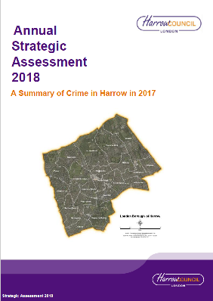Towards the end of 2017 there has been decline in some elements of resident confidence in policing, however Harrow benchmarks well for Police reliability and treating people fairly
* Good performance in relation to Anti-social behaviour although there are hotspots where levels remain relatively high.
* The rate of non-domestic related violent crime continues to be higher in the neighbourhoods also associated with higher levels of ambulance attendances to night time violence and areas associated with the evening and night time economy.
* Violent crime continues to rise with increases recorded in both violence with injury and violence without injury.
* The proportion of knife crime that results in injury is increasing particularly for under 25s.
* Rates of gang flagged offences are low but resident concern is rising.
* Slight reduction in the level of domestic abuse in Harrow, however domestic abuse with injury, repeat victims and the proportion of the victims who are women is rising.
* Drug crime may be an emerging risk as Harrow’s relatively lower levels are rising, while neighbouring boroughs are showing significant reductions.
* Significant increases in Faith Hate crime.

### Youth Violence Weapon Based Crime

Harrow has continued to see an increase in offences of a serious nature in relation to young people. This has reflected an increase in the use of custodial remands and sentences. In 16-17 a total of 9 custodial remand episodes occurred. Current data from April 2017 to date, shows a total of 9 remand episodes having taken place, this inevitably means remand episodes for the forthcoming year will surpass previous year data. This is monitored through the Youth Offending Partnership Board, to ensure all options were considered prior to a custodial remand and only the most serious offences led to these outcomes.

However Repeat Offending rates and First Time Entrants into the criminal justice system demonstrate a positive trend. The number of first time entrants for the current period (Oct 16-Sep 17) shows a decrease of 25.4% on the same period in the previous year (Oct 15-sept 16).

The Triage service continues to demonstrate a positive trend in successfully diverting young people away from the Youth Justice System. Local analysis tracks those young people who were subject for triage for 12 months, to see if they enter the criminal justice system. The last quarter for 16/17 shows of the 20 young people who received Triage intervention, only 3 went onto offend.

Harrows current figure (Jan 16 – Mar 16) shows a figure of 38.5%, which accounts for 10 repeat offenders from a cohort of 26. This compares to 53.5% for the same period in the previous year (Jan 15-Mar 15). This is lower than the National Average (42.1%) and London figure (48.1%).

Youth offending and offensive weapons

|  |  |  |  |  |  |
| --- | --- | --- | --- | --- | --- |
| Offence Category | 2016 | % of youth offs | 2017 | % of youth offs | % Change |
| Possession of firearms | 5 | 1.8% | 3 | 1.0% | -0.8% |
| Possession of an offensive weapon | 21 | 7.7% | 1 | 0.3% | -7.3% |
| Possession of knives and similar | 8 | 2.9% | 27 | 8.8% | 5.9% |
| Possession of other weapons | 3 | 1.1% | 12 | 3.9% | 2.8% |

The large increase in the possession of knives is owing to possession of knives being recorded as possession of offensive weapons in 2016.

### Serious Youth Crime victims

Between 2016 and 2017, the number of serious youth violence victims has risen by 40. There was a total of 140 offences during 2017, and 100 in 2016. This translates to a 0.2 rate increase.

The graph below shows that there has been an upward trend in recorded serious youth crime victims since 2015.

### Gang Flagged offences

Between 2016 and 2017, the number of gang flagged offences has reduced by 9. There was a total of 10 offences during 2017, and 19 in 2016. This translates to a 0.4 rate reduction. However, despite this change in data, it is recognised where this remains an issue in parts of the borough and remains a priority.

Concern about gangs being a problem in their area is rising in Harrow. In 2016, 5% of residents were concerned about gangs in their area and in 2017 this rose to 12%.

|  |
| --- |
| **Objectives**:   1. To reduce the number of young people involved in youth violence and gang crime and to reduce the number of young people carrying offensive weapons (guns and knives) 2. To support schools to deal more effectively with issues of sexual assault, child sexual exploitation and digital exploitation, and to promote a culture of awareness of child exploitation. |

### Progress So Far

* Safer Harrow has responded to the rise in youth violence in South Harrow and Rayners Lane, and are continuing to build on developing a Youth Offer as part of the Councils Early Support Offer. The Youth Offer is aligned with the Youth Offending Team and one Deputy Team Manager now oversees the work of the Out of Court disposals (diversion from courts) and the Youth Offer, ensuring as many young people as possible are engaged in positive activities and have an array of support available to target support for those considered at risk.
* Young Harrow Foundation, in partnership with Harrow Council and over 50 voluntary organisations, is conducting the largest ever analysis of young people’s needs in Harrow. This is made up of a combination of an extensive survey of young people aged 10-19 living in Harrow; data and focus groups led by the charity sector; and a council data review. Already we see that youth violence is a significant need in the area across the board – with young people themselves citing it as the second highest priority they would like support with. The final report will be available from June 26th, after which the council and voluntary sector will be able to use the indicator of Fighting or ASB to review what that tells us about other underlying needs and opportunities in this population.
* Ignite Project: The Council has been working with Ignite a well-known voluntary and community organisation, with a team of experienced youth workers, to recruit a full-time Gangs Worker for the Rayners Lane Estate and South Harrow area. The programme is specifically aimed at working with young people connected to known gangs in the area and those who are engaged in high levels of anti-social, violent and criminal behaviour.
  + In July 2017 a full time gangs worker was recruited and the organisation was able to attract additional match funding to recruit a second part-time worker to work with the full time gang’s worker on this project. The plan is to continue using this team throughout 2018 for the project. The organisation also secured a total of £75k funding from Lloyds over 3 years (£25k per year), and secured £840 funding for a 12 week Youth Club pilot in Grange Farm and support staff/food and rental £720 in kind.
  + We have already seen 171 session taking place with young people, with 48 individual young people engaged in positive activities and 76 mentoring sessions and 95 employment/education support sessions already delivered, which include Grange Farm (early intervention) youth club; Basketball on Thursdays; Gym memberships.
  + In addition to this, 69 young people have been engaged with detached services; out of these 51 young people have demonstrated improved self-efficacy; 32 have started making positive choices; 28 have increased their aspirations. Further work is still being developed to ensure that the Gangs Worker works in close partnership with the Community Safety Team, including sharing intelligence and anecdotal insight on a daily and frequent basis.
* Series of primary schools based engagement programme aimed at raising general awareness around crime and personal safety (for Academic year September 2017): This has been a very successful programme. Feedback has been great from the Primary Schools. Parents events have also been run to discuss transition from year 6 to year 7 and the pressures on children amongst other things. This was scheduled for this academic year. It is intended that this will be delivered by the new youth engagement team under the BCU model which launches in November, however this cannot be guaranteed at this time as we do not know exactly what it will look like. Schools officers’ priority will be secondary schools so whilst we aspire to continue we will need to review in September when the position will be clearer.
* Secondary School – 3 schools have signed up to anti-knife crime seminars run by one of the schools officers with assistance from HEMS, mother of a fatal stabbing victim supported by the Ben Kinsella Trust.
* The Youth Offending Team (YOT) are currently working in partnership with Prospects whereby a workshop on the impact of having a criminal record on future life chances is delivered and this will be considered as part of the wider offer to schools.

|  |
| --- |
| **Synergy**: Last year we also invested in a drama programme with Synergy Theatre. Synergy have a proven track record in working to rehabilitate ex-prisoners and have featured in the national press for their successful work in changing the attitudes and behaviours of participants and the audience. The production company has been working in a select number of targeted schools where young people are at risk of entering the criminal justice system to help them discover alternative pathways and become an integral and meaningful part of society. Synergy have developed a ground breaking, interrelated programme of artistic work that seeks to build a bridge from prison to social reintegration, prevent young people from entering the criminal justice system, and inspire change by capturing the imagination and affecting the feelings, behaviours and attitudes of participants and public.  **Case Study**  A screening of a film called The Thief, with question and answer sessions has also been delivered to over 300 young people. Feedback from both schools has been positive and students are reported to have engaged really well. The project will continue to run for another year and will take place in a further two schools. Synergy are also exploring opportunities to deliver ‘Blackout’ at select schools in Harrow |

* **Unblurred Lines:** This academic year two of the issues that have caused the most anxiety in schools have been ‘unhealthy relationships’ and ‘digital exploitation’. The MASH team, and in particular the Education Lead, are contacted frequently to discuss concerns around these issues.

Vulnerability to sexual exploitation is a concern in high schools all year round but in the run up to the six week holiday there is a greater anxiety and we wanted to support the schools in educating the teenagers to keep themselves safe over the holiday and going forward. After a presentation by Shanice Grant, Sexual Exploitation Digital Specialist, at the Safeguarding in Education conference it became clear that primary schools are becoming increasingly worried about the impact of mobile phones and social media on their years 5 and 6 particularly in the run up to the summer holiday where many young people are being given their first phone and parents may be ill informed about the potential risks.

We have invested in community theatre group Unblurred Lines going into six targeted high schools to run half day workshops on Healthy and Unhealthy relationships through a series of active drama games, discussion based exercises and key learning through creative outlets. They will also be running half day workshops in four targeted primary schools to explore social media and online safety through the same means. Unblurred Lines have a track record of delivering workshops for local authorities and are committed to the idea of teaching young people to keep themselves safe. They are presently in discussion with all nine schools to identify the dates to deliver the workshops and to tailor them to the individual needs of each school. There is considerable demand for support in these areas so the hope is that funding will be available to send them into more schools next academic year.

* Harrow Council has commissioned a further 36 sessions of Street Doctors who deliver bespoke intervention regarding the impact of knife injuries to raise awareness of the risks associated with carrying / using a knife. Street Doctors is a group of 2nd year medical students who volunteer their time to work with young people who may come into contact with a stab victim. They work with multiple partners across London to help fund, facilitate and strengthen the delivery of pragmatic, life-saving first aid to young people at risk of youth violence in the city. The programme they deliver includes a minimum of 42 young people (potentially 6 per cohort) at risk of youth violence educated in each of two modules – ‘What to do when someone is bleeding’ (6 sessions) and ‘What to do when someone is unconscious’ (6 sessions).
* In conjunction with these practical activities, the Youth Offer delivers a programme to help young people explore their current mind-set and consider ways of approaching different situations that they are faced with both in and out of school. The Youth Offer addresses a number of key factors which can lead young people into crime, such as social skills, cognitive deficits, self-esteem, emotional resilience, confidence building, and ensuring a strengths based model is adopted which moves away from a deficit model of working with the “problem”. The Mental Toughness programme works closely with young people aged 12 to 19 to help them drive positive and sustainable changes that will make a real difference to their attitude, mind-set and behaviour. The aims of the programme are to help them; not to fear failure; challenge stereotypes & ditch labels; be resilient to challenge; be confident to make mistakes.
* Throughout the Youth Offer and work of the Youth Offending Team, sessions exploring the young person’s ability to empathise are delivered alongside consequential thinking, challenging distorted views and decision making processes. This all contributes to increasing victim empathy in young people. In addition to this, teams will continue to work with community based organisations where young people are encouraged to engage in their wider communities. For example, the Dogs Trust involves young people making biscuits and toys for dogs as a way of repairing harm caused to their community. This is one of the approaches currently being provided via Harrow YOT.
* Work continues to extend the youth offer to other areas of the Borough including activities being run in partnership with Watford FC based at the Cedars Youth and Community Centre and plans to add youth services to the programme of activities from the Early Support Hub at the Pinner Centre.
* Key to further developments around the Youth Offer is our partnership with Young Harrow Foundation, a not for profit youth organisation, who are assisting Harrow Early Support in developing an overarching youth strategy along with other partners within the private and voluntary sector. Harrow Council are working with Young Harrow Foundation to seek to increase the participation of vulnerable young people, including those who are at risk of committing crime, to improve the opportunity to engage with a wide range of residents and increase their understanding of the community’s fears of crime This should assist in breaking down barriers which can prevent tensions arising within local communities.
* Funding has been secured to deliver to 13 cohorts of young people a 6-8 week mindfulness programme which supports young people to understand their emotions and offers a tool to engage young people better with their emotions to increase wellbeing. These sessions will be offered to young people subject to Out of Court Disposals, to schools and from youth centres. In addition a pilot programme will be offered to victims of crime identified and supported by the YOT victim support worker, as research evidences that often young victims of crime can go on to become perpetrators if the trauma of a crime is left unaddressed.
* The Council are also engaged with a number of other partners, including Prospects, MIND, Watford Football Club employability programmes, and Xcite. All organisations are delivering sessions across the youth offer as a preventative strand but also a range of provision is available for those who may have offended through the YOT including a dedicated education worker. In addition, Children’s Services have been in discussion with Ignite to look at ways in which to partner further and develop a more bespoke youth offer to the area which will include joint outreach/detached youth work, engagement events with young people in the South Harrow area and youth club sessions built on the feedback from young people as to what they want to see delivered. It is the intention that once a model of delivery is agreed and rolled out at the Beacon Centre, that this model is then replicated in other areas of Harrow where there is a need.
* Last year we commissioned Wish, a charity supporting young people into recovery from self-harm, violence, abuse and neglect, to deliver a new programme aimed at early intervention and prevention. Wish have been working in close partnership with the Harrow Violence Vulnerabilities and Exploitation team to deliver an Outreach and Support service to young people within identified schools and/or “hotspot” areas in Harrow. During the summer of 2017 Wish undertook a survey of 104 young people aged 13- 19 by a group of 13 trained youth volunteers. Amongst the responses, 44% of the teenagers knew someone who had been touched inappropriately or sexually assaulted at school, and only 24% reported that their school had taken any action. 74% had either, or knew someone who had sent sexually explicit photos to others, and 64% knew someone who had shared explicit photos in school of someone else.
* Work is in progress with the Child Sexual Exploitation subgroup of the Harrow Safeguarding Children Board and the Council’s VVE team to establish a mechanism for schools to report incidents of sexual assault and digital exploitation. 1-2 targeted schools evidence the impact in preventing and reducing crimes of sexual assault and digital exploitation by 50% against reporting baselines (long term outcome over 2 years). 75% of 300 children and young people have reported an increased awareness about sexual assault and digital exploitation and an improved sense of safety within the school setting. 50% of 30 school staff have an increase in confidence, knowledge and procedures to create a school culture of challenge and support. 70% of young 10 victims supported report a significant improvement in their sense of safety from repeat victimisation. The evidence for this outcome will be measured via a tool called the Young Persons Core.
* Raising awareness across the community is crucial to tackling this issue, and the service has been working with young people to develop materials to support other children to understand the risks and issues. Schools are being supported to deliver appropriate responses to young people on the issues, and to tackle incidents such as sexual assault in appropriate ways. In addition to this, training is being delivered to all Schools Designated Safeguarding Leads on Digital Sexual Exploitation and CSE and targeted work is being done in particular schools on the issue of “bait out”. Wish is working with schools lead to develop a letter for parents for schools on the issue, as well as information for their websites. Wish recognise that the final year in primary school is a crucial age, when many children are getting their first mobile phones, and are therefore arranging training for primary schools. Wish are also working with Police Cadets to develop a cadre of young CSE champions to deliver CSE assemblies; delivering training for Foster Carers and multi-agency training for frontline workers on CSE and Digital Exploitation Awareness and what to do as part of HSCB CSE training; linking with Harrow Teaching Alliance and Learning Hubs to input to training provision; and working with a Pupil Referral Unit for targeted small group of young women at risk. Wish have also been successful in securing £25,000 worth of match-funding to widen the breadth of this programme from a part time to full time post.

### Going Forward

* Harrow has seen a particular rise in youth violence in general, and in light of this increase, and in response to offences linked to knife crime and serious offences involving stabbings, the Council are developing a Youth Offer as part of the Early Support Offer and in conjunction with Youth Offending Team to directly address young people who are vulnerable to being either victims or perpetrators of such crime.
* As many young people report that they carry knives on the basis that they feel unsafe and as a result, more activities which develop confidence and emotional resilience are required. The Council therefore will increase its efforts to engage with Harrow’s Youth Parliament to seek the views of young people on increasing sessions which involve creative arts (including dance, drama, art, and music) across the borough and will introduce these sessions in youth centres across the borough at the earliest possible opportunity. The Council will continue to work with voluntary and private sector organisations in order to design and subsequently deliver these sessions. This is because feelings of insecurity can be addressed by providing opportunities for self-expression. Creative arts such as music, dance and drama offer a way of doing this. Furthermore, public speaking – which teaches debating skills – enables young people to investigate their views and challenge those of others so that they can become more inclined to develop opinions on the world around them. In this sense, it increases their confidence in expressing their ideas and so would help to tackle the sense of insecurity which results in some young people carrying knives. Linked to this, through our partnership with Young Harrow Foundation we are developing a new needs analysis which will support future decisions on what services and support can be developed to make the biggest difference for young people. This work will be supported through training members of the Harrow Youth Parliament in public speaking to deliver this message through schools in the borough in order to maximise take up in the needs analysis.
* Harrow Council will seek to work with the police and voluntary sector partners in order to raise awareness of violence, vulnerability and exploitation, and serious youth violence as well as introduce a gangs awareness course in youth centres and other sites across the borough across the borough as part of the Youth Offer
* In addition, the council will also attempt to deliver these in wards where gang crime is a particular issue. Young people– particularly those who are vulnerable to crime – will be targeted to access the provision on offer and engage in workshops and consultations with youth workers and the police. These workshops and consultations will also contribute to the needs analysis set out above.
* The Council will continue to engage with and listen to the Youth Parliament, working together to address concerns and take forward interventions
* The Council will also seek to work alongside local employers and voluntary sector organisations to improve the offer to young people to engage with work experience and skills based programmes and will work with local businesses and employers in order to design and subsequently seek to implement this.
* The Council will also work with partners with the aim of introducing a mentoring programme (potentially volunteer led) for vulnerable young people and those who could become involved in crime. This programme will be developed based on the evidence from the needs analysis which the Harrow Youth Parliament are supporting the delivery of. As schools will be critical partners in this, once established, the Council will work with schools on the delivery and roll out of any mentoring programme. The Council will also continue to adopt a variety of methods including coaching as a way to ensure young people are advised, supported and encouraged to develop their skills and maximise their potential. All engagements currently provided via the Youth Offer and YOT are based on a coaching principle which is focused on achieving sustainable and positive outcomes, ensuring engagement is meaningful and purposeful. However, all interactions with young people are underpinned by developing trusting relationships with young people.

### Youth violence and knife crime

We have seen an increase in the number of victims of knife crime within the borough and young people convicted of weapons offences has also risen. In 2016/17 36 young people were convicted of possession of an offensive weapon, compared to 28 young people in the previous year.

In addition to this, the Triage service has been transferred to Harrow’s YOT service which has meant a more streamlined approach to early intervention to address youth violence. During 2016/17 the YOT received 73 referrals, 68 of which went on to have a triage intervention. Overall; including those already with triage at the start of the year; the team delivered triage interventions to 83 young people. There were a total of 50 young people discharged from the triage programme in 2016/17 45 (90.0%) of whom completed the programme successfully.

However, assessments of young people by the YOT indicate that young people are carrying knives due to feeling unsafe and the majority of knives have been kitchen knives rather than “trophy” knives. Knife crime incidents made up a total of 281 offences in April 2015 to March 2016 in young people aged 0-25, this increased by 29% in the following year to 362 incidents between April 2016 to March 2017. The graph below shows the upward trend of knife related incidents in the borough:

*Figure 11 - Knife Crime with Injury (Under 25s) from October 2015 – April 2017, MOPAC Dashboard*

Harrow has seen a particular rise in youth violence in the South Harrow and Rayners Lane area and in light of this increase, and in response to offences linked to knife crime and serious offences involving stabbings, the Council are developing a Youth Offer as part of the Early Support Offer and in conjunction with Youth Offending Team to directly address young people who are vulnerable to being either victims or perpetrators of such crime.

As many young people report that they carry knives on the basis that they feel unsafe and as a result, more activities which develop confidence and emotional resilience are required. The Council therefore will increase its efforts to seek the views of young people on increasing sessions which involve creative arts (including dance, drama, art, and music) across the borough and will introduce these sessions in youth centres across the borough at the earliest possible opportunity. Consultations will be conducted with young people in order to highlight what format they want these sessions to take and which aspects of creative arts they wish to be included. The Council will continueto work with voluntary and private sector organisations in order to design and subsequently deliver these sessions. This is because feelings of insecurity can be addressed by providing opportunities for self expression. Creative arts such as music, dance and drama offer a way of doing this. Furthermore, public speaking – which teaches debating skills – enables young people to investigate their views and challenge those of others so that they can become more inclined to develop opinions on the world around them. In this sense, it increases their confidence in expressing their ideas and so would help to tackle the sense of insecurity which results in some young people carrying knives. Linked to this, through our partnership with Young Harrow Foundation we are developing a new needs analysis which will support future decisions on what services and support can be developed to make the biggest difference for young people. This work will be supported through training members of the Harrow Youth Parliament in public speaking to deliver this message through schools in the borough in order to maximise take up in the needs analysis.

In addressing the issue of youth violence, the Council have been working with Ignite a well-known voluntary and community organisation, with a team of experienced youth workers, to recruit a full-time Gangs Worker for the Rayners Lane Estate and South Harrow area. The programme is specifically aimed at working with young people connected to known gangs in the area and those who are engaged in high levels of anti-social, violent and criminal behaviour.

This service aims to achieve a reduction in youth offending and gang-related behaviour, and support young people to disengage with and ultimately leave associated gangs. In July 2017 a full time gangs worker was recruited and the organisation was able to attract additional match funding to recruit a second part-time worker to work with the full time gang’s worker on this project. The plan is to continue using this team throughout 2018 for the project. The organisation also secured a total of £75k funding from Lloyds over 3 years (£25k per year), and secured £840 funding for a 12 week Youth Club pilot in Grange Farm and support staff/food and rental £720 in kind.

Progress on the project has been positive, and outcomes have included young people demonstrating improved self-esteem, engagement, confidence and skills, helping them to make positive choices and increasing their aspirations and hope for the future. We have already seen 171 session taking place with young people, with 48 individual young people engaged in positive activities and 76 mentoring sessions and 95 employment/education support sessions already delivered, which include Grange Farm (early intervention) youth club; Basketball on Thursdays; Gym memberships.

In addition to this, 69 young people have been engaged with detached services; out of these 51 young people have demonstrated improved self-efficacy; 32 have started making positive choices; 28 have increased their aspirations. Further work is still being developed to ensure that the Gangs Worker works in close partnership with the Community Safety Team, including sharing intelligence and anecdotal insight on a daily and frequent basis.

Last year we also invested in a drama programme with Synergy Theatre. Synergy have a proven track record in working to rehabilitate ex-prisoners and have featured in the national press for their successful work in changing the attitudes and behaviours of participants and the audience. The production company has been working in a select number of targeted schools where young people are at risk of entering the criminal justice system to help them discover alternative pathways and become an integral and meaningful part of society. Synergy have developed a ground breaking, interrelated programme of artistic work that seeks to build a bridge from prison to social reintegration, prevent young people from entering the criminal justice system, and inspire change by capturing the imagination and affecting the feelings, behaviours and attitudes of participants and public.

The programme is being delivered effectively, with an intensive drama devising project and a play writing project has been delivered at two Harrow schools with excellent buy in from selected young people. A screening of a film called The Thief, with question and answer sessions has also been delivered to over 300 young people. Feedback from both schools has been positive and students are reported to have engaged really well. The project will continue to run for another year and will take place in a further two schools. Synergy are also exploring opportunities to deliver ‘Blackout’ at select schools in Harrow

Harrow Council will seek to work with the police and voluntary sector partners in order to raise awareness of violence, vulnerability and exploitation, and serious youth violence as well as introduce a gangs awareness course in youth centres and other sites across the borough across the borough as part of the Youth Offer. In addition, the council will also attempt to deliver these in wards where gang crime is a particular issue. Young people– particularly those who are vulnerable to crime – will be targeted to access the provision on offer and engage in workshops and consultations with youth workers and the police. These workshops and consultations will also contribute to the needs analysis set out above.

Through the opportunities offered by this project, participants have been challenged to try new activities and learn new skills to overcome destructive patterns of thinking and behaviour. Many have discover untapped potential and talent and these achievements and skills gained will help to foster a more positive mode of behaviour and encourage re-engagement with education and increase future employability.

In addition to this programme YOT are seeking to add provision by delivering collaborative sessions across schools. YOT are currently working in partnership with Prospects whereby a workshop on the impact of having a criminal record on future life chances is delivered and this will be considered as part of the wider offer to schools.

Another programme called Street Doctors has been selected to assist Harrow Youth Service in addressing the rise in knife crime. Street Doctors is a group of 2nd year medical students who volunteer their time to work with young people who may come into contact with a stab victim. They work with multiple partners across London to help fund, facilitate and strengthen the delivery of pragmatic, life-saving first aid to young people at risk of youth violence in the city. The programme they deliver includes a minimum of 42 young people (potentially 6 per cohort) at risk of youth violence educated in each of two modules – ‘What to do when someone is bleeding’ (6 sessions) and ‘What to do when someone is unconscious’ (6 sessions). Those at risk are defined as any one of the following:

* Young people who have already received a conviction for violence or weapon carrying
* Young people who are deemed by other services as being at higher risk. Example services include: Youth Offending Institutes/ Teams, Pupil Referral Units, Specialist Charities, and Youth Clubs
* Young people living in areas where there is a high rate of violence

Young people who attend the Street Doctors course receive a certificate of attendance at the end of the programme. Once the course is complete the team share subsequent intelligence and analysis with key stakeholders. Discussions are also underway with the Beacon Centre which is located in Rayners Lane to host these sessions. We know from recent experience that this is a worthwhile venture as two young people known to the YOT who witnessed the aftermath of a stabbing were able to utilise their skills learned from these sessions and stop the bleeding of a victim.

The Council will also seek to work alongside local employers and voluntary sector organisations to improve the offer to young people to engage with work experience and skills based programmes and will work with local businesses and employers in order to design and subsequently seek to implement this. We will ensure for vulnerable young people and those who are on the periphery of crime are prioritised to access these opportunities. In order to prevent young people from becoming involved in crime, it is imperative that increased opportunities are offered which will enhance their employability skills. This increases the range of future career paths available to young people increasing their sense of aspiration. In the process, it is possible to combat the disillusionment which can diminish confidence and resilience and therefore act as a ‘pull’ factor towards offending

In conjunction with these practical activities, the Youth Offer delivers a programme to help young people explore their current mind-set and consider ways of approaching different situations that they are faced with both in and out of school**.**  The Youth Offer addresses a number of key factors which can lead young people into crime, such as social skills, cognitive deficits, self-esteem, emotional resilience, confidence building, and ensuring a strengths based model is adopted which moves away from a deficit model of working with the “problem”.The Mental Toughness programme works closely with young people aged 12 to 19 to help them drive positive and sustainable changes that will make a real difference to their attitude, mind-set and behaviour. The aims of the programme are to help them; not to fear failure; challenge stereotypes & ditch labels; be resilient to challenge; be confident to make mistakes.

The council will work with partners to teach a range of important life skills such as financial management and the establishment of bank accounts. The aim of this is to ensure that vulnerable young people and those on the periphery of crime are better prepared for later life. This can support young people to become active members of their community and increase a sense of belonging, thereby reducing the prospect of alienation.

The Council will explore working more with charities to include sessions which focus on victim empathy as part of its programme for youth services including youth centres. In order to prohibit involvement in crime, it is necessary to emphasise the negative effects that one’s behaviour could have on others as well as the community at large. This can enable young people to comprehend the suffering that crime can inflict and hence victim empathy is a deterrent to criminal activity.

Throughout the Youth Offer and work of the Youth Offending Team, sessions exploring the young person’s ability to empathise are delivered alongside consequential thinking, challenging distorted views and decision making processes. This all contributes to increasing victim empathy in young people. In addition to this, teams will continue to work with community based organisations where young people are encouraged to engage in their wider communities. For example, the Dogs Trust involves young people making biscuits and toys for dogs as a way of repairing harm caused to their community. This is one of the approaches currently being provided via Harrow YOT.

The Council are also engaged with a number of other partners, including Prospects, MIND, Watford Football Club employability programmes, and Xcite. All organisations are delivering sessions across the youth offer as a preventative strand but also a range of provision is available for those who may have offended through the YOT including a dedicated education worker.In addition, Children’s Services have been in discussion with Ignite to look at ways in which to partner further and develop a more bespoke youth offer to the area which will include joint outreach/detached youth work, engagement events with young people in the South Harrow area and youth club sessions built on the feedback from young people as to what they want to see delivered. It is the intention that once a model of delivery is agreed and rolled out at the Beacon Centre, that this model is then replicated in other areas of Harrow where there is a need.

Work continues to extend the youth offer to other areas of the Borough including activities being run in partnership with Watford FC based at the Cedars Youth and Community Centre and plans to add youth services to the programme of activities from the Early Support Hub at the Pinner Centre.

Harrow Council will offer activities from youth centres and other sites across the borough, in order to enhance the existing provision of positive activities available outside of school hours. . Provision will be tailored to encourage a reduction in young peoples’ exposure to and involvement in violence, vulnerability and exploitation.

Key to further developments around the Youth Offer is our partnership with Young Harrow Foundation, a not for profit youth organisation, who are assisting Harrow Early Support in developing an overarching youth strategy along with other partners within the private and voluntary sector.

Harrow Council are working with Young Harrow Foundation to seek to increase the participation of vulnerable young people, including those who are at risk of committing crime, to improve the opportunity to engage with a wide range of residents and increase their understanding of the community’s fears of crime This should assist in breaking down barriers which can prevent tensions arising within local communities. .

The Council will also work with partners with the aim of introducing a mentoring programme (potentially volunteer led) for vulnerable young people and those who could become involved in crime. This programme will be developed based on the evidence from the needs analysis which the Harrow Youth Parliament are supporting the delivery of. As schools will be critical partners in this, once established, the Council will work with schools on the delivery and roll out of any mentoring programme. The Council will also continue to adopt a variety of methods including coaching as a way to ensure young people are advised, supported and encouraged to develop their skills and maximise their potential. All engagements currently provided via the Youth Offer and YOT are based on a coaching principle which is focussed on achieving sustainable and positive outcomes, ensuring engagement is meaningful and purposeful. However, all interactions with young people are underpinned by developing trusting relationships with young people.

Some of Harrow’s young people access services at St Mary’s Hospital Emergency Department run by Red Thread, a collaborative youth charity, which provides youth intervention programmes to support and engage with victims of serious youth violence and exploitation.

In providing a joint response to child sexual exploitation (CSE), missing children, and gang related activity, Harrow Children’s Services took the steps to mobilise resources associated with Violence Vulnerability and Exploitation and create the Violence, Vulnerability and Exploitation (VVE) team in April 2016. The VVE Team has a CSE Coordinator, Missing Children/Runaways Family Support Worker and a Gangs worker in order to provide a joined up response to children and young people displaying vulnerabilities associated with these key risk areas. This work compliments the work being carried out by the Community Safety Team, informing and supporting intelligence shared at monthly Gangs Multi Agency Partnership meetings. The VVE team works in collaboration with key partners, including the Police, , Youth Offending Team and Education to provide a joint response to CSE, Missing Children and Gang related activity, as well as being involved in Channel and preventing extremism. The team also serves to develop key themes and trends, improve collective response through an informed understanding of the issues, which will feed into the development of the problem profile in respect of young people.

In November 2016 a Harrow led Violence, Vulnerability and Exploitation mapping exercise of approximately 40 known young people was undertaken involving professionals across the partnership including Harrow Children’s Services, Police, Education, Housing, Community Safety Team, Helix Pupil Referral Unit (PRU), and Health. The aim was to explore the links and key themes between the young people in respect of VVE indicators and vulnerabilities. The mapping exercise highlighted links and relationships involving missing young people, CSE, youth violence, suspected county lines drug trafficking and gang associations, primarily the development of a new group/gang. The Helix PRU was also becoming a prominent location where a key number of VVE young people were meeting and forming peer groups.

Local authority expenditure on youth services continues to come under pressure as councils redirect their resources to respond to growing demand and financial pressures in children’s and adults social care.Therefore it is increasingly challenging to intervene to support young people who are at risk of engaging in crime. However, the council has ensured services are targeted and needs-led leading to positive outcomes as demonstrated by the Youth Justice Outcome Indicators, where there has been a reduction in First Time Entrants (8%) and reduction of repeat offending (5%). The council will continue to strengthen existing provision and seek to obtain external sources of finance (both in the form of grants from voluntary and private sector organisations and planning gain) in order to develop youth provision based on the fluidity of youth crime and anti social behaviour. This will include youth centres in areas where youth crime is a persistent issue. The council is in the process of increasing its reach across the borough by working in partnership with the voluntary sector to develop bespoke pieces of work based on the needs within certain wards. As part of this we will look to maximise the opportunity to increase deliver sites, mostly from partners existing assets and resources across the public and voluntary and community sector, but also private sector provision where the opportunity arises. Through the Council’s regeneration programme, Building a Better Harrow, we will also look at all opportunities to develop new sites which although may have multiple uses, will give additional capacity across the borough for the delivery of services for young people, which again will be based on the evidence provided by the needs analysis.

|  |
| --- |
| Case Study  In December 2016 a Multi-Agency Child Protection Strategy meeting was held involving approximately 35 multi-agency professionals across the partnership regarding a family address and location in the Roxbourne Ward, Harrow. The location was a recurring theme with young people associated with VVE. The concerns at the address included CSE, Missing young people, substance use and youth violence associated with the new ‘Group/Gang.  The Police, with support of Children’s Services and the Community Protection Team, were able to submit representations to Harrow court and obtain a Closure Order for 3 months covering period 10.12.16 – 4.3.17. (*ASB Crime & Police Act 2014 – Sect.80*). *Disorderly, offensive or criminal behaviour* ..*.serious nuisance… disorder to members of the public.* The order ensured that only the named individuals residing at the address could be there prohibiting access to the premises to anyone else.  Effective partnership working with corporate and with key stakeholders led to successful disruption activity, safeguarding children missing from home and care and those at risk of Child Sexual Exploitation. The success of the disruption activity and reduced anti-social behaviour firmly rests with the strength of partnership working between Children’s Services, Police, Community Safety and Housing. Swift action on the part of everyone involved led to a reduction in criminality and children being safeguarded. |

The Council has invested in a programme aimed at generating a cultural shift within schools on the issue of sexual assault, CSE, and digital exploitation violence, and promote a culture of awareness. Last year we commissioned Wish, a charity supporting young people into recovery from self-harm, violence, abuse and neglect, to deliver a new programme aimed at early intervention and prevention. Wish have been working in close partnership with the Harrow Violence Vulnerabilities and Exploitation team to deliver an Outreach and Support service to young people within identified schools and/or “hotspot” areas in Harrow. During the summer of 2017 Wish undertook a survey of 104 young people aged 13- 19 by a group of 13 trained youth volunteers. Amongst the responses, 44% of the teenagers knew someone who had been touched inappropriately or sexually assaulted at school, and only 24% reported that their school had taken any action. 74% had either, or knew someone who had sent sexually explicit photos to others, and 64% knew someone who had shared explicit photos in school of someone else.

Work is in progress with the Child Sexual Exploitation subgroup of the Harrow Safeguarding Children Board and the Council’s VVE team to establish a mechanism for schools to report incidents of sexual assault and digital exploitation. 1-2 targeted schools evidence the impact in preventing and reducing crimes of sexual assault and digital exploitation by 50% against reporting baselines (long term outcome over 2 years). 75% of 300 children and young people have reported an increased awareness about sexual assault and digital exploitation and an improved sense of safety within the school setting. 50% of 30 school staff have an increase in confidence, knowledge and procedures to create a school culture of challenge and support. 70% of young 10 victims supported report a significant improvement in their sense of safety from repeat victimisation. The evidence for this outcome will be measured via a tool called the Young Persons Core.

Raising awareness across the community is crucial to tackling this issue, and the service has been working with young people to develop materials to support other children to understand the risks and issues. Schools are being supported to deliver appropriate responses to young people on the issues, and to tackle incidents such as sexual assault in appropriate ways. In addition to this, training is being delivered to all Schools Designated Safeguarding Leads on Digital Sexual Exploitation and CSE and targeted work is being done in particular schools on the issue of “bait out”. Wish is working with schools lead to develop a letter for parents for schools on the issue, as well as information for their websites. Wish recognise that the final year in primary school is a crucial age, when many children are getting their first mobile phones, and are therefore arranging training for primary schools. Wish are also working with Police Cadets to develop a cadre of young CSE champions to deliver CSE assemblies; delivering training for Foster Carers and multi-agency training for frontline workers on CSE and Digital Exploitation Awareness and what to do as part of HSCB CSE training; linking with Harrow Teaching Alliance and Learning Hubs to input to training provision; and working with a Pupil Referral Unit for targeted small group of young women at risk. Wish have also been successful in securing £25,000 worth of match-funding to widen the breadth of this programme from a part time to full time post.

### Drug and alcohol misuse

The VVE strategic objective for drug and alcohol misuse lie around the need to ensure there is a continuity of treatment from prison to community. There is evidenced correlation between the commission of acquisitive crimes such as burglary and the misuse of Class A drugs, especially crack cocaine and heroin. Most prisoners recovering from drug or alcohol addiction will continue to require treatment after they leave prison and there is also a greater risk of drug-related deaths in the few weeks after release. It is also crucial to attack both the supply and demand for drugs, while ensuring addicts are given the best possible help to recover and necessary for those prisoners and their families who are faced with the destructive consequences of addiction. It is essential for local people who become victims of preventable crimes every year at the hands of those desperately trying to pay for their drug and/or alcohol habits and reinforces our commitment to helping the most vulnerable.

### Young People

The Harrow Substance Misuse Service is tailored for both young people and adults. The role of specialist substance misuse services is to support young people and adults to address their alcohol and drug use, reduce the harm caused by it and prevent it from becoming a greater problem.

Harrow Young People’s Substance Misuse Service (YPSMS) is provided by Compass who deliver a well-developed care pathway and range of early, targeted and specialist interventions that have been further developed throughout the year to increase Service User engagement including a Young People’s Service User Group. Compass’s co-location continues within the Youth Offending Team (YOT) to respond to youth cautions, youth conditional cautions and court orders in partnership with the YOT and the Police. The Compass Service Manager is a member of the Youth Offending Board and the Service has recently developed closer joint working arrangements at A&E to identify young people attending A&E with drug and /or alcohol related conditions.

Young people can enter YPSMS’s specialist substance misuse services with a range of problems or vulnerabilities relating to their substance misuse. Our Provider delivers an outward looking model to strengthen mainstream services and deal with lower level issues rather than meet all drug and alcohol related needs in-house. Special attention is given to Young People who have wider vulnerabilities and to enable greater engagement.

There has been a significant increase in referrals from universal and alternative education between 15/16 Q3 and 16/17 Q3 with referrals from YOT remaining consistent. In 16/17 Q3 there were more referrals from education than from YOT which reflects the changing national picture. The Young people’s statistics from the National Drug Treatment Monitoring System (NDTMS) recent report highlighted that nationally, it is the first year of reporting that referrals from education services have exceeded referrals from youth/criminal justice sources.

The number of young people receiving drug and alcohol treatment intervention has also increased and this is a reflection of the increased engagement and co-locations of Harrow’s Young People’s Substance Misuse Service across the borough.

|  |  |  |  |  |  |
| --- | --- | --- | --- | --- | --- |
| Harrow Young People’s Substance Misuse Service | **Q3**  **15-16** | **Q4 15-16** | **Q1**  **16-17** | **Q2**  **16-17** | **Q3**  **16-17** |
| Numbers in Treatment | 72 | 78 | 89 | 83 | 90 |

During 2016/17 (information up until Q3) 48% of young people exiting treatment were drug free and 26% exiting treatment had reduced use. Compass has continued to undertake workforce development of multi-agency practitioners working with young people at risk of offending and offenders to enable early identification of substance use and to be able to deliver brief interventions.

|  |
| --- |
| Case Study  Compass’s first contact with a young person was in June 2016 when they were given ‘Triage’ by the Police for a possession of cannabis offence. The young person (YP) was required to complete statutory appointments with the YOT and Compass. Prior to their assessment with Compass, YP had been using cannabis (on average) twice per month had a sibling in prison for a serious offence, a history of gang affiliation, anger issues and a complex family relationship. YP (who had been using cannabis as a coping mechanism to deal with these issues) engaged well with the YOT who, as part of the process communicated with the police to inform them that YP had successfully completed their YOT programme. Once the sessions were completed with the YOT, YP was given the option by Compass to continue to work with them on a voluntary basis which was accepted and they appreciated the safe place they were given to talk and throughout their engagement and attendance was exemplary. YP also reported during their Compass engagement that they only used cannabis on 2 occasions from their assessment with Compass to discharge (period of engagement lasting 9 months).  To encourage positive activities, Compass also visited a gym with YP that they were interested in joining and also attended their school (with their permission) to complete some three-way work with the staff. In addition, Compass also completed some of their sessions at the school so this did not impinge of after school studies/activities. In planning discharge, Compass made arrangements with the school for YP to have access to a staff member for regular support sessions/counselling so they did not lose a safe place to talk. YP was discharged from Compass in March 2017 with no evident of reoffending during their time of engagement. |

Compass were also awarded a small grant which aims to provide preventative interventions to support young people at risk of becoming involved in the supply of illicit substances and build resilience in young people to recognise the signs of dealer grooming. This project has been working with selected young people to help them build resilience so that they are able to spot the signs of dealer grooming and are able to choose not to supply substances, and to reduce the harm that supply of substances does to individuals, families and communities by supporting them to exit this lifestyle. A number of assemblies have taken place which are aimed at reducing the numbers of young people choosing to or being coerced into supplying substances.

The chart below shows Substance Misuse Service users by age during October 2015 to September 2016. The highest numbers of users of the Service are aged 35-39 and interestingly, where there is a high proportion of young people aged 15-19 years old entering the service, this drops dramatically young people aged 20-24, which could indicate a potential gap in services for young people transitioning to adult services. To reduce the risk of ‘cliff edge’ of support between Young People’s and Adult Services, the age range for access to Harrow’s Young People’s Substance Misuse Service has been extended to 24 years.

# Summary of Strategic Objectives

### Overarching objectives

1. Reduce First Time Entrants to the Youth Justice System
2. Reduce the use of custody
3. Reduce the rate of reoffending

### Youth violence, weapon based crime, vulnerability and exploitation.

1. To reduce the number of young people involved in youth violence and gang crime and to decrease the number of young people carrying offensive weapons (guns and knives)
2. To embed an awareness of actions which can shift attitudes within young people at schools and in other education settings towards the issues of sexual assault, child sexual, digital and criminal exploitation

### Drug and alcohol misuse

1. Reduce the incidence of young people using and possessing drugs
2. Reduce the incidence of young people being involved in the supply, dealing, distribution or the production of drugs and to build resilience in young people so that they are able to spot the signs of dealer grooming.
3. To reduce alcohol and drug-related reoffending via targeted early support.

### Wellbeing and welfare

1. To promote the emotional and psychological resilience of young people at risk of offending behaviour so that they can make more civic and pro-social choices about their lifestyle.
2. To provide a robust offer to youth at risk of offending to support them as they are diverted away from offending behaviour
3. To provide a robust service which takes strategic action towards protecting the public and other vulnerable young people from the most prolific and high harming behaviours displayed by young offenders.

# Delivering the strategy

The Strategy’s objectives will be delivered through Harrow’s Youth Offending Partnership, which is responsible for co-ordinating activity between the statutory, voluntary and community partners and agencies

The role of Harrow’s Youth Offending Partnership is to enable and promote the strategic objectives of the partner agencies outlined above. As part of this, the partnership will look for all opportunities to communicate the impact of our initiatives that are taking place across the borough. They unblock obstacles and motivate the partner agency officers. They quality assure the performance and impact of operations. They enable reflection of arising issues emerging from an analytical review of trends and themes and encourage participation of young people to co-produce the analysis, plans and objectives.

Governance for the partnership and this Strategy sits with the Youth Offending Partnership Board and is endorsed by the Youth Justice Board.

The strategic objectives fit in with Harrow council’s priorities and values particularly around “Protecting the Most Vulnerable and Supporting Families” and building a better Harrow by being courageous, working together and collaboratively, in order to make things happen.

The strategic objectives will be measured through a Delivery Plan, with clear outcomes and measures which will be delivered and added as an appendix. The senior managers in Harrow are committed to unblocking and enabling meaningful change and improvement for the groups impacted by the implementation of this strategy. The delivery plan will be developed collaboratively with key partners including our 3rd sector partners and those represented at the Youth Justice Partnership Board and there will be on ongoing interest of the senior corporate directors to ensure progress is being embedded and progressed.

The partners will be involved in setting and reviewing the strategic direction and performance of the services.

This strategy is closely aligned to the Safer Harrow Violence Vulnerability and Exploitation (VVE) Strategy. In order to establish an effective delivery mechanism will be working closely with the VVE group and ensure that we avoid duplication and support existing bodies where they already exist.

We are fortunate in that we have a vibrant and efficient voluntary and community sector with which we have a close working partnership. This has meant that to date we have made substantial gains in closing the gap between vulnerable groups through targeted interventions, and this will continue to be the theme of our forthcoming programmes.

In delivering this strategy the YOT Board will produce a themed Delivery Plan which will oversee projects which will contribute to the strategic objectives outlined in this Strategy.

Engagement with the Community Action Groups in both Wealdstone and South Harrow & Rayners Lane will build upon work already being delivered and coordinated across the Youth and early Support offer at Wealdstone Hub and the Beacon centre in Rayners Lane.

# Appendices

## YOT Board Membership

| **Name** | **Role and organisation** | **Contact Details** |
| --- | --- | --- |
| Paul Hewitt **Chair** | Executive Director People’s Service | [Paul.Hewitt@harrow.gov.uk](mailto:Paul.Hewitt@harrow.gov.uk) |
| Peter Tolley | Divisional Director, Children & Young People | [Peter.tolley@harrow.gov.uk](mailto:Peter.tolley@harrow.gov.uk) |
| Dawn Hargadon | Metropolitan Police Detective Inspector | [Dawn. Hargadon@met.pnn.police.uk](mailto:Hargadon@met.pnn.police.uk) |
| Mark Scanlon | Head of Service - Youth Offending Team and Early Support | [Mark.scanlon@harrow.gov.uk](mailto:Mark.scanlon@harrow.gov.uk) |
| Vacant | Team Manager, YOT | [Aman.Sekhon-Gill@harrow.gov.uk](mailto:Aman.Sekhon-Gill@harrow.gov.uk) |
| David Harrington | Head of Business Intelligence | [David.Harrington@harrow.gov.uk](mailto:David.Harrington@harrow.gov.uk) |
| Paa-King Maselino | Head Teacher The Helix Pupil Referral Unit | [Paa-King.Maselino@harrow.gov.uk](mailto:Paa-King.Maselino@harrow.gov.uk) |
| Mike Herlihy | Youth Magistrate and former Chair of NW London Youth Panel | [hamlin.herlihy@talktalk.net](mailto:hamlin.herlihy@talktalk.net) |
| Sue Sheldon | Designated Nurse Safeguarding Children Harrow CCG | [suesheldon1@nhs.net](mailto:suesheldon1@nhs.net) |
| Antony Rose/ Russell Symons | Assistant Chief Officer, National Probation Service Senior Probation Officer, Probation Service | [Antony.rose@probation.gsi.gov.uk](mailto:Antony.rose@probation.gsi.gov.uk)  [russell.symons@london.probation.g si.gov.uk](mailto:russell.symons@london.probation.g%20si.gov.uk) |
| Janice Noble / Alun Goode | Community Safety | [Janice.noble@harrow.gov.uk](mailto:Janice.noble@harrow.gov.uk) [Alun.goode@harrow.gov.uk](mailto:Alun.goode@harrow.gov.uk) |
| Dan Burke | CEO Young Harrow Foundation – Voluntary Sector | [Dan.burke@youngharrow.org](mailto:Dan.burke@youngharrow.org) |
| Delroy Etienne | Service Manager, COMPASS Harrow | [Delroy.Ettienne@compass-org.uk](mailto:Delroy.Ettienne@compass-org.uk) |
| Nomination awaited | Service Manager CAMHS |  |
| Mellina Williamson- Taylor (MWT) | Head of Virtual School – HSIP | [Mellina.Williamson-Taylor@harrow.gov.uk](mailto:Mellina.Williamson-Taylor@harrow.gov.uk) |
| Nomination awaited | Chief Executive Officer - Ignite Trust – Voluntary Sector |  |

## Finance Table

|  |  |  |  |  |
| --- | --- | --- | --- | --- |
| **Agency** | **Staffing Costs (£)** | **Payments In kind  - Revenue (£)** | **Other Delegated Funds (£)** | **Total (£)** |
| Local Authority | £963,884 |  |  | £963,884 |
|
|
| Police service (2 x FTE Police Officers) |  | £66,231 |  | £66,231 |
| National Probation Service (1 x FTE Probation Officer) |  | £49,173 |  | £49,173 |
| Health Service - jointly funded CAMHS p/t post) |  | £16,833 |  | £16,833 |
| Health Service -  1 x FTE YJLD worker |  | £60,650 |  | £60,650 |
| Police and Crime Commissioner |  |  |  |  |
| YJB Youth Justice Grant (Provisional) - (YRO  Unpaid work order is included in this grant) | £211,435 |  |  | £211,435 |
| Other |  |  |  |  |
|
|
| **Total** | **£752,449** | **£192,887** |  | **£945,336** |
|
|

## Staffing structure and breakdown

**Head of Service**

**Early Support and Youth Offending**

**Mark Scanlon**

**Service Manager**

**Youth Offending**

**Team Manager**

**Vacant**

**Deputy Team Manager**

**YOT & Youth Hub**

**DK**

**Deputy Team Manager**

**LS QSW**

**Deputy Team Manager**

**HJ QSW**

**YOT Technical Support**

**CM (Part time)**

**AC (Part time)**

**YOT STUDENT**

**Vacant**

**YOT Practitioner**

**ST QSW**

**YOT Practitioner**

**AD (Agency) Extra QSW**

**YOT Practitioner**

**BL**

**YOT Practitioner**

**Vacant**

**2 Police Officers**

Seconded

**MB**

Early Support Youth Hub Structure

**0.6 Substance Misuse Worker**

Seconded (Compass YP Service)

**DR**

**YOT Practitioner**

**TL**

**QSW**

**YOT Practitioner**

**ZN**

**YOT Practitioner**

**Vacant**

**YOT Practitioner**

**ZB**

**CAMHS worker**

**Vacant**

**Education Specialist**

**RS**

**Probation Officer** Seconded

**KKF**

**0.5 Victim Liaison Officer**

**NL**

**FTE Restorative Justice**

**Co-ordinator**

**CR**

**YJLD** Seconded

PM

S: 17.10.16

**0.5 Restorative Justice**

**Co-Ordinator**

**LR**

**NOTE: 1 year Fulltime (to 05/18) then 0.5 perm**

**Prospects 0.2** commissioned

**RD**

**Out of court DISPOSAL Practitioner**

**(OOCD)**

**CM (Part time)**

## Structure and Governance arrangements

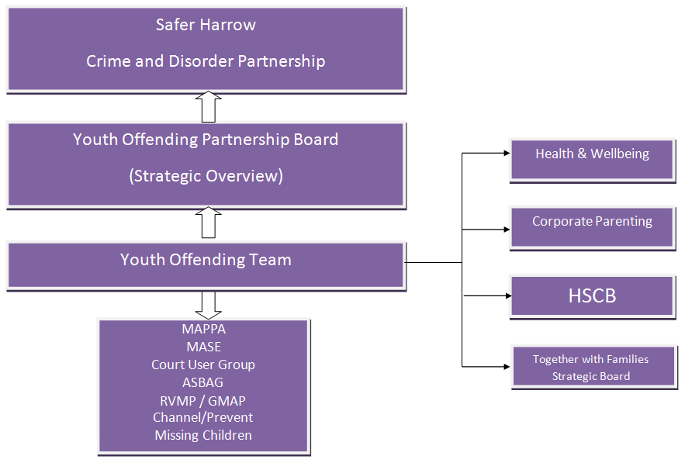

## 

## Allocation of Good Practice Grant

|  |  |  |
| --- | --- | --- |
| **Area of Delivery** | **Activity** | **Associated Costs** |
| Service delivery improvements | Implementation of Assetplus, including improving casework practice and performance. | £100,435 |
| Reducing FTE’s | Strengthen preventative services within the YOT, including improved links with Together with Families work by way of increased data collation with partners and tracking | £40,000 |
| Reducing Re-Offending | Completing further analysis on reoffending cohort to identify trends and triggers.  Development and further investment in programmes and resources targeting reoffending cohort needs. | £30,000 |
| Reducing the Use of Custody | The YOT will continue to ensure robust programmes are available including positive activities for YP to access as part of their bail / resettlement from custody. | £31,000 |
| Restorative Justice work including work with Victims | Identifying creative methods of engagement to support victims of crime and encourage increased engagement in restorative processes | £10,000 |
| **Total** | | **£211,435** |

## YOT Champions Roles

| **Champion area** | **Staff member** | **Meetings attended / input to / gather info from** | **What are you expected to achieve by being a champion*?***  *(how you do this is up to you to determine but managers will be willing to support and discuss where needed – remember this is not an exhaustive list, just the overarching vision)* |
| --- | --- | --- | --- |
| Child Sexual Exploitation | Deputy Team Manager | MASE | LS to ensure CSE lead is invited to Team meeting to discuss process of referral  LS to feedback to team any patterns / risk areas / trends on a monthly basis at team meeting (standing agenda item)  Identify and share research in relation to those who are at risk of CSE and any links to Youth Justice. |
| Prevent | YOT Manager | Channel | Immediate actions:   * Ensure staff understand referral process into channel * Ensure all staff have completed online training Ongoing Role * Any identified/ increased risk in relation to LB Harrow |
| Missing Children | Yot Practitioner | Monthly at risk missing children meeting | Immediate actions   * ASG will continue to attend Monthly at risk meeting and individual information on cases will be collated from YOT Practitioner   Ongoing Role   * Share research in relation to push and pull factors as to why children go missing and any link to YJ system |
| Gangs | Yot Practitioner and Deputy Team Manager | Gangs Matrix Meeting  YJB Gangs Forum | Ongoing Role   * LS to ensure written update is provided to all staff re: police operations / impact on geographical locations / those linked to Young People known to YOT. * To bring back research / effective interventions from forum and share with team as resources * To support referrals into gangs intervention within LA |
| Safeguarding | YOT  Practitioner / Deputy Team Manager |  | Ongoing Role   * To support staff in increasing their understanding of safeguarding within the YJ system * Link research to practice and support this within assessments (DTM) |
| Victim work | Victim Liaison Practitioner |  | Ongoing Role   * To ensure staff understand the importance of individualising victim empathy work * To identify meaningful ways this can be supported within plans |
| Restorative Justice | Restorative Justice Coordinator |  | Ongoing Role   * To train staff in RJ practice * To support staff in embedding RJ within their day to day work * To identify meaningful ways this can be supported within plans |
| Effective Interventions / Research | Probation Officer / YOT Practitioner | YJB Effective Practice Forum | Ongoing Role   * To increase understanding and share resources that are considered to be effective in reducing offending / further offending in young people. * To increase and promote what meaningful engagement means * To assist staff in focussing on a strengths based model such as Good Lives Model |
| Group Work | YOT  Practitioner/ Restorative Justice Coordinator |  | Ongoing Role   * To develop sustainable group work programmes that run throughout the year and can be accessed by all young people within the YOT. * To support bespoke delivery of programmes based on changing needs / trends being identified * To incorporate services from within then multi agency YOT for regular delivery of group sessions (such as compass) |
| Health | Clinical Nurse  / Youth Justice Liaison Diversion Practitioner |  | Ongoing Role   * To support increased understanding of health needs for those young people within the YJ system * To share relevant information / research * To assist in the incorporation of health needs within plans for young people |
| Education/ SEN | Educational Specialist | YJB Send Forum | Ongoing Role   * To advocate with education providers increased access of provision for young people within the criminal justice system * To provide regular sessions at the YOT for young people who are NEET / Excluded to ensure education needs are being met in the interim * To share effective practice and research in relation to education needs of those young people within the criminal justice system. |
| Substance Misuse | Substance Misuse Worker |  | Ongoing Role   * Increase awareness of impact of substances within staff group * Deliver regular sessions to groups of YOT cohort regarding the use of substances / possession of cannabis * Ensure research regarding the impact of substances is shared across the service (this can also be in relation to parental substance abuse impact on children) |
| Transition arrangements | Probation Officer | Case transfer meetings | Ongoing Role   * To ensure there is understanding across the service regarding the process of transitional arrangements * To support staff understanding of what makes a “good transition” based on inspection / research available across probation |
| Quality Assurance | YOT  Practitioner | YJB QA support | Ongoing Role   * To increase the use of research in assessments * To support developing a “peer” QA network within the team * To support increased consistency of QA across service. |
| Children Looked After | YOT  Practitioner | CLA Team Meetings | Ongoing Role   * To attend CLA team meeting and deliver training to support understanding of “at risk” cohort * To share research with CLA and YOT regarding the increasing issue of criminalisation of children looked after |
| Children With Disabilities | YOT  Practitioner |  | Ongoing Role   * To develop links with CWD team * To increase awareness in team re: CWD and impact in youth justice |
| Workforce Development | YOT  Practitioner |  | Ongoing Role   * To create a wider understanding across the service of what “workforce development” entails * Share emerging research across the team * To increase knowledge / skills across the team to deliver effective and meaningful services to children and families |
| Early Support (ES) | YOT Manager |  | Ongoing Role   * To increase access to youth services provision for young people known to YOT across the borough * To improve partnership links with Early Support services * To increase awareness of what ES can offer for young people and families |
| Reflective Practice | Clinical Nurse |  | Ongoing Role   * Develop Reflective Practice across the service |

## Glossary

|  |  |
| --- | --- |
| **Term** | **Meaning** |
| CIN | Child in Need (Section 17 Children Act 1989) |
| CLA | Children Looked After (often referred to as in care, Section 20 (voluntarily / by consent), Section 31 / Full or Interim Care Order (as a result of a Court Order). Children Act 1989. |
| CP | Child Protection |
| CPC / ICPC / RCPC | Child Protection Plan / Initial / Review |
| CPCC / ICPCC / RCPCC | Child Protection Case Conference / Initial / Review |
| FTE | First Time Entrant (to the Youth Justice System) |
| OOCD | Out of court disposal (offence dealt without recourse to court) |
| VVE | Violence Vulnerability and Exploitation |
| YJB | Youth Justice Board |
| YOS | Youth Offending Service |
| YOT | Youth Offending Team |

## Statutory functions and strategic approach of the Youth Justice Board (YJB)

The YJB is a non-departmental public body established by the Crime and Disorder Act (1998). It monitors the operation of the youth justice system and the provision of youth justice services. It advises the Secretary of State on matters relating to the youth justice system, identifies and shares examples of good practice and publishes information about the system: reporting on how it is operating and how the statutory aim of the system (‘to prevent offending by children and young people’) can best be achieved.

The YJB is the only official body to have oversight of the whole youth justice system and so is uniquely placed to guide and advise on the provision of youth justice services.

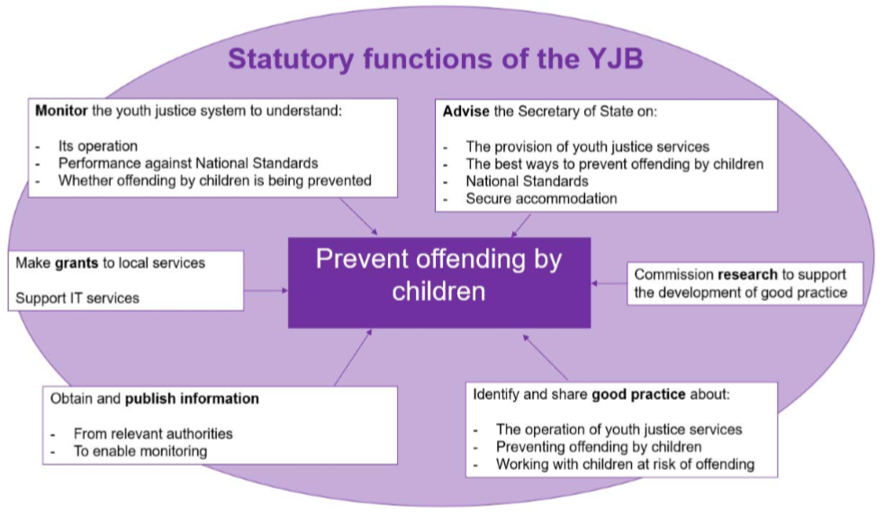

The YJB aspires to be:

* Child-centred
  + We see children first and offenders second. We make every effort to champion the needs of children wherever they are in the youth justice system and ensure we give them a voice.
  + We strongly believe that children can, and should be given every opportunity to make positive changes.
* Outcome focused
  + We are outcome focused in fulfilling our statutory functions. We provide leadership and expertise and promote effective practice across the youth justice workforce to maximise positive outcomes for children and their victims.
* Inclusive
  + We strive to challenge discrimination and promote equality, and we work with others to try to eliminate bias in the youth justice system.
* Collaborative
  + We encourage system-led change, and are enablers to innovation. We actively encourage, facilitate and engage in partnership working to help meet the needs of children, their victims and their communities. Trustworthy • We endeavour to act with integrity in everything we do.

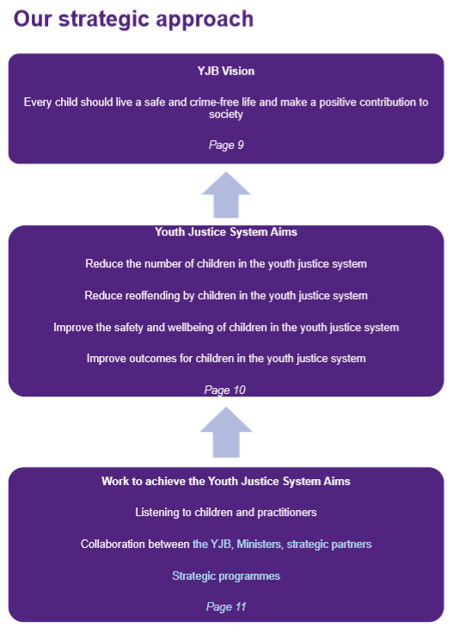

## Consultation questionnaire

|  |  |  |
| --- | --- | --- |
| **Question** | **Response** | **Comment / suggestion** |
| Are the strategic objectives the right ones? | Yes  No  Partially |  |
| Is the delivery approach the right one? | Yes  No  Partially |  |
| Is Harrow’s YOT Partnership Board effectively established? | Yes  No  Partially | How could it be improved?  Which other groups be represented/involved? |
| How else can the Youth Justice Plan be improved? |  |  |
| Would you be like to be involved in contributing / producing / reviewing the effectiveness of the Youth Justice Delivery Plan or future Youth Justice Plans? | Yes  No  Maybe: I’d like to be kept informed of developments / opportunities | If you have said “Yes” or “Maybe” please provide an email address we can write to you at regarding this. You can advise us to stop emailing you at any time.  email: |
| How should we publicise opportunities to be involved with co-producing and monitoring the effectiveness of these plans in future? | Email  Website  Facebook  Twitter  WhatsApp Group  Other: please specify | Please tick as many as you wish.  If you ticked other, please specify here |

**Thank you**